**Regular Nanowire Grid**

Micrograph

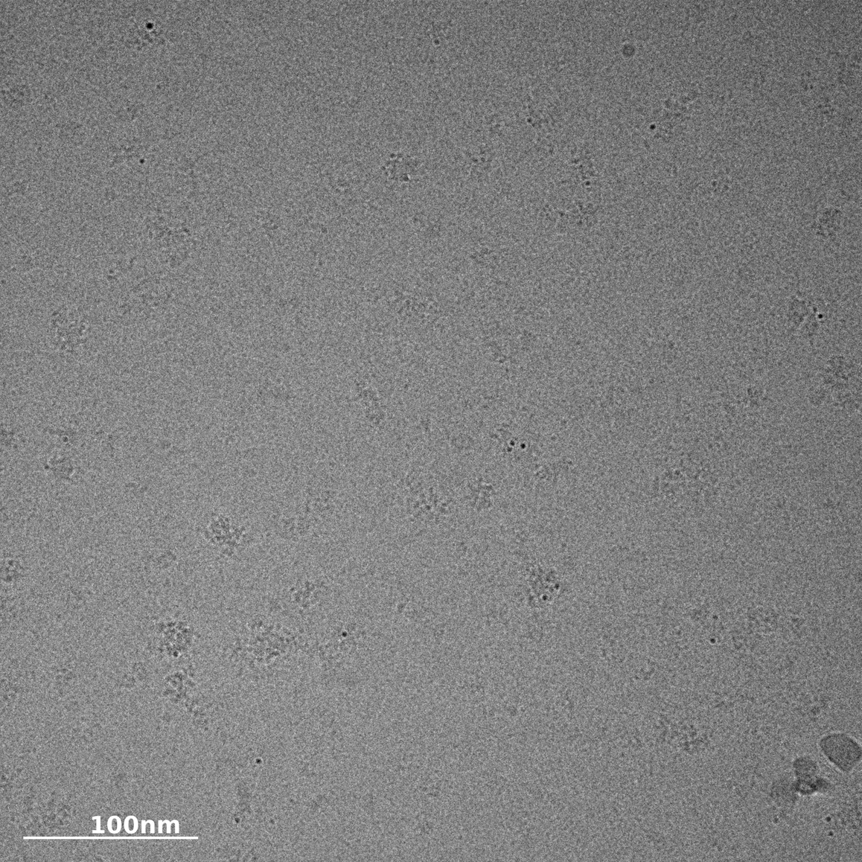

2D Classification

**Graphene Nanowire Grid**

Micrograph

