The proteins we aim to look at are the aggregate glue droplets of the model spider species Larinioides cornutus. These glue droplets are a complex mixture of glycoproteins and low molecular mass components (LMMCs) which include ions, lipids, and small proteins. These components were found to be homogenously distributed throughout the glue droplets of L. cornutus; however, we hypothesize the distribution of these properties varies between species. In order to compare to other species in the future, we are looking to characterize the overall layout. Here we present current research on the glue droplets of L. cornutus using RAMAN spectroscopy, NMR spectroscopy, and genomic sequences of larger glycoprotein homologs of ASG1 & ASG2.
Chemical Characterization through Raman Spectroscopy and NMR
A B
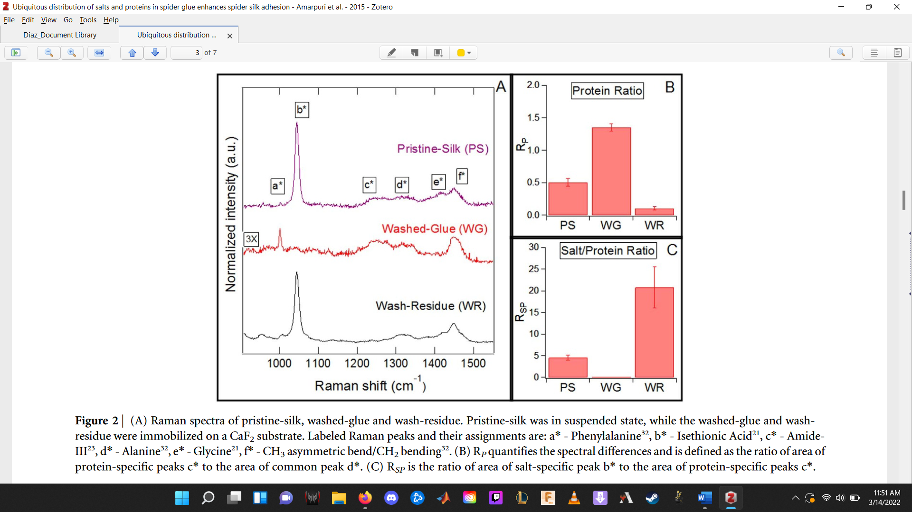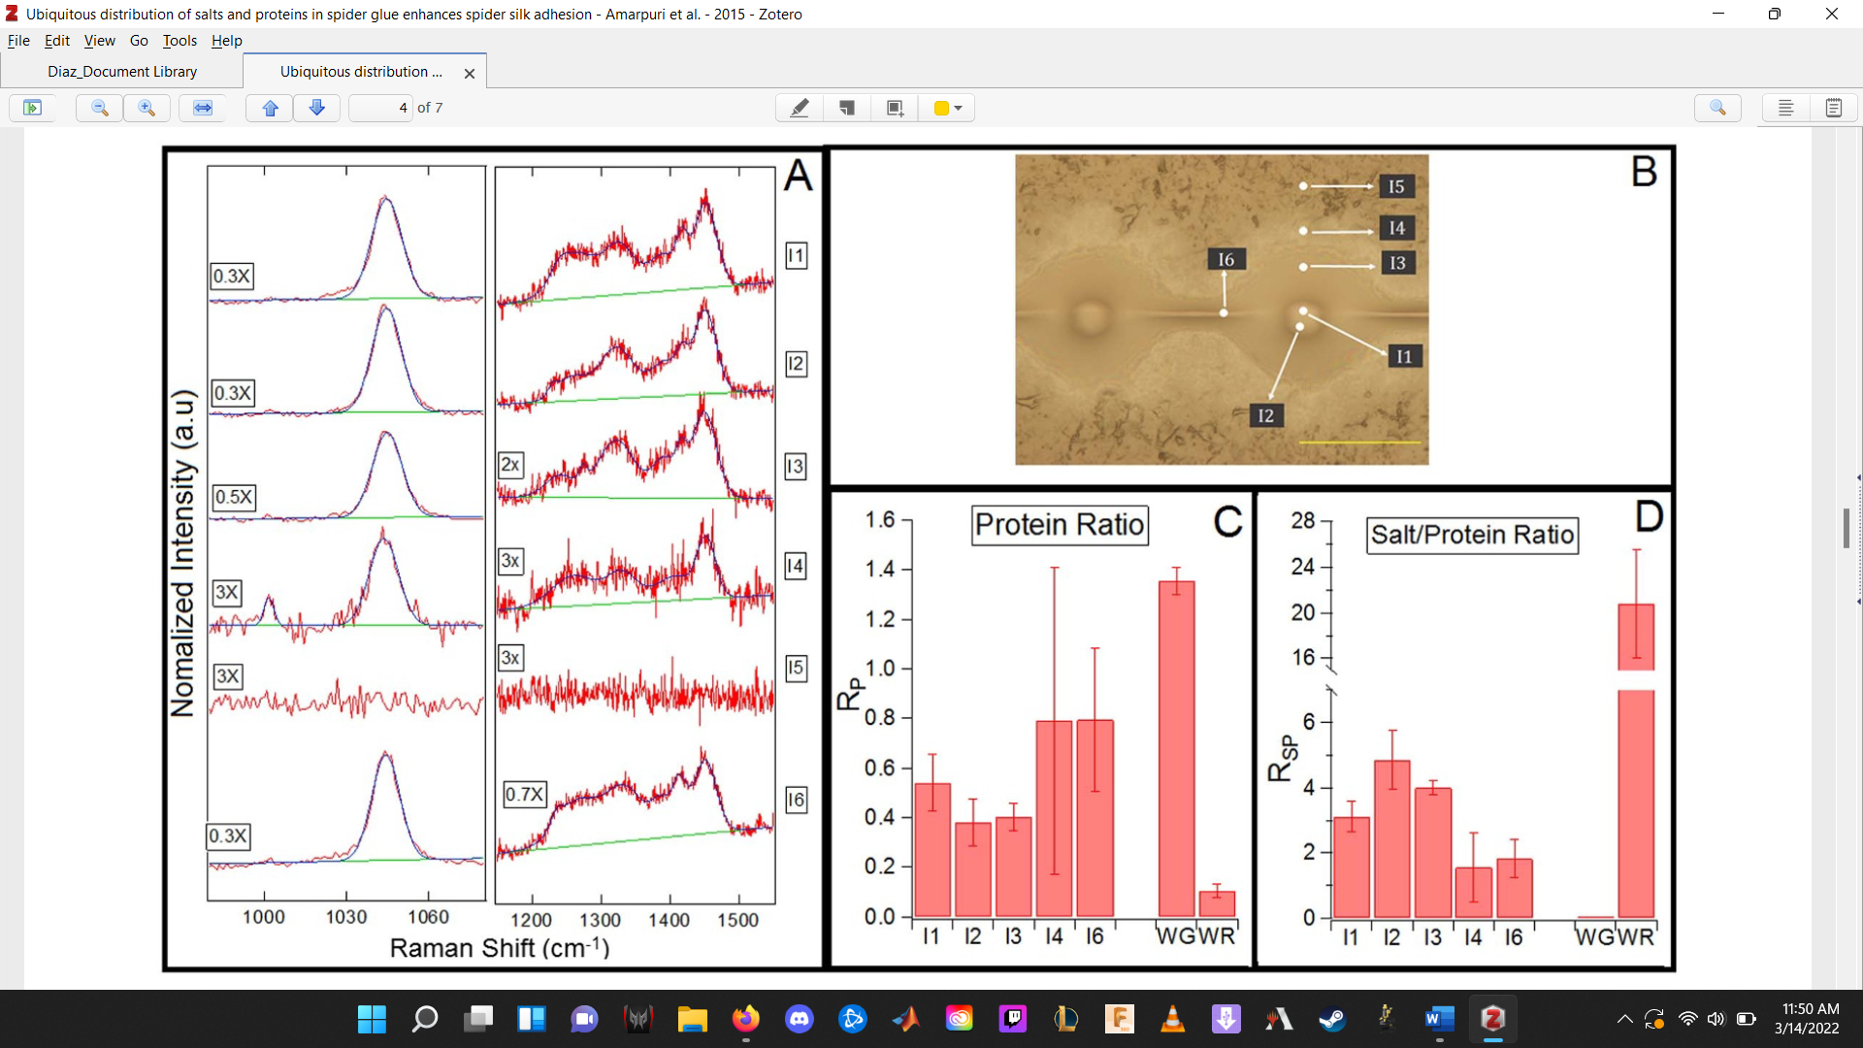
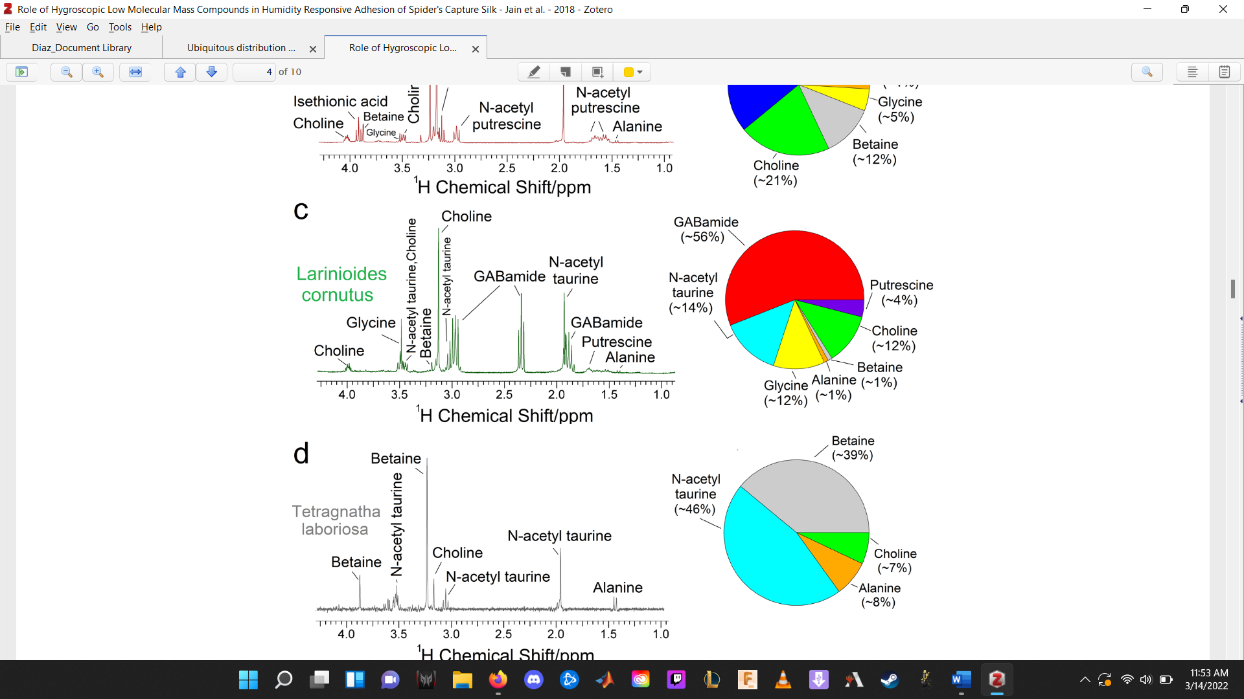
Figure 1 Raman spectra of pristine-silk, washed-glue and wash-residue and NMR of Laranioidies corunutus’s capture glue: (a) Labeled Raman peaks and their assignments are: a* - Phenylalanine32,b* - Isethionic Acid21,c* - AmideIII23,d* - Alanine32,e* - Glycine21,f* -CH3 asymmetric bend/CH2 bending32. Range only shows RAMAN shifts between 1000-1500 but information exists for 50-1800 cm⁻¹. (b) Pristine-silk glue droplet immobilized on a CaF2 substrate. Raman spectra collected at regions marked as I1-I6. Scale bar is 100 mm. (Amarpuri et al., 2015) (c) NMR allows us to look at specifically the water soluble components of them which include these small proteins, etc. Here for this species we have found a total of 7 components which do not include the glycoproteins at the center. 1H solution-state NMR spectra of the extracted LMMCs mixtures from the webs Larinioides cornutus. The color-coded pie chart (each color representing a distinct LMMCs compound) showing the details of relative composition of each LMMC (Jain et al, 2018). This allows us to sperate out the two.
Work Cited: Jain D, Amarpuri G, Fitch J, Blackledge TA, Dhinojwala A. Role of hygroscopic low molecular mass compounds in humidity responsive adhesion of spider’s capture silk. Biomacromolecules. 2018 Jun 13;19(7):3048-57.

