**Supplementary Information**

***Electrophysiology assay for tandem-dimers of CNGA3-B3 coexpressed with CNGA3***

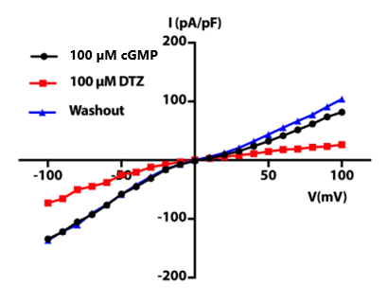We generated WT CNGA3-CNGB3 tandem dimers and coexpressed with WT CNGA3 monomer in HEK293 cells and recorded whole cell current. Fig. 1 showed a typical cell current. The cGMP activated current can be inhibited by DTZ proved that most of the channel in this cell is consisted of CNGA3/B3 heterotetramer. This tells us that our dimer is folded correctly and functional.

Fig. 1. Whole-cell current recording for wild-type TAX-4 (a), TAX-4_1G (b), TAX-4_2G (c), TAX-4_3G (d) and DCM10 (e) in HEK293T cells.

***Image acquisition on Glacios and processing for fully liganded CNGA3/B3***

We prepared cryogenic grids using vitrobot machine (FEI) for CNGA3/B3 proteins, incubated with saturated concentration of cGMP and collected a 3000-micrograph dataset on Glacios microscope. After image processing using Relion and cryoSPARC, we got a 3.60 A resolution map. However, the local resolution, especially around the CNBD domain, is still not clear enough for us to accurately build an atomic model.

Fig2. Representative 2D class and and data processing for fully liganded CNGA3/B3

