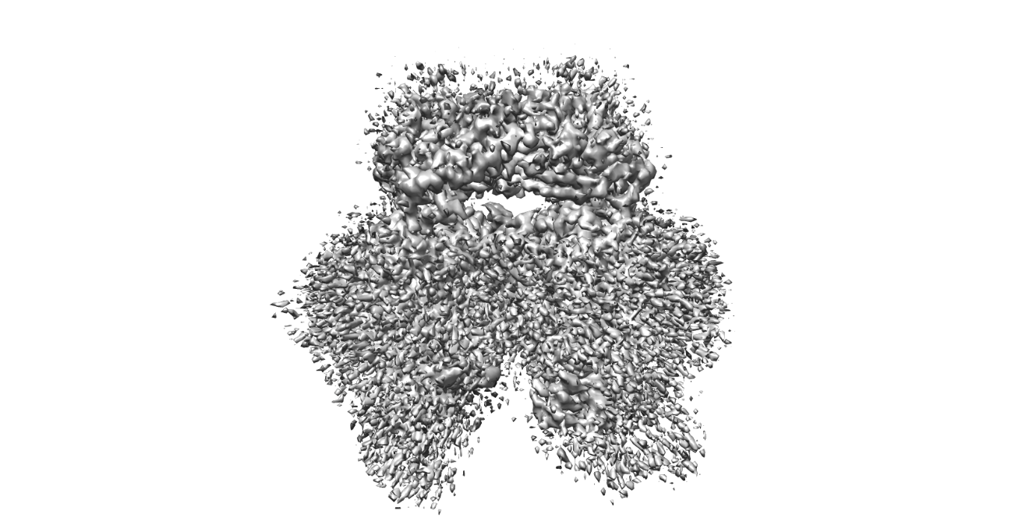

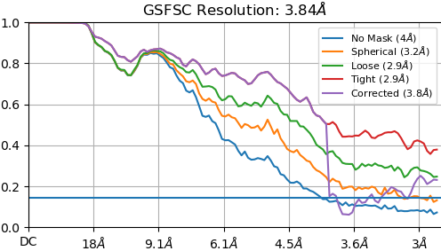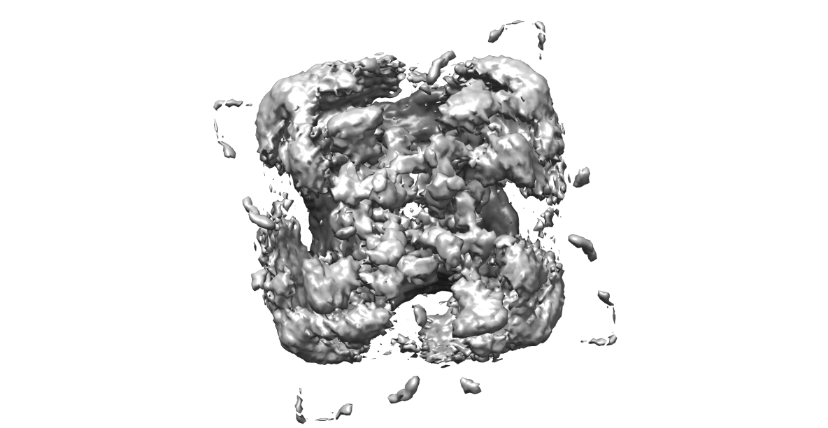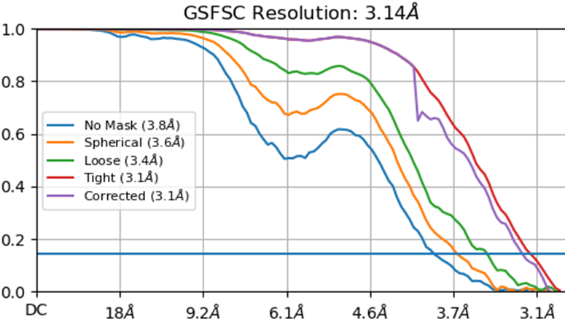

Figure 2. Cryo-EM density of human TRPML3 at pH 6.0. The particle number is much less than that used for the TRPML3 sample at pH 7.4.

Figure 1. Cryo-EM density of human TRPML3 at pH 7.4. The resolution is higher than any other reported cryo-EM structure of human TRPML3.