**Structure, function and pharmacology of TRP channel TRP1**

Algae produce the largest amount of oxygen on earth and are invaluable source for human nutrition and biomedicine, as well as for the chemical industry, energy production and agriculture. The mechanisms by which algae can detect and respond to changes in their environments can rely on membrane receptors, including TRP ion channels. Recently, we have determined a 3.5-Å resolution cryo-EM structure of the transient receptor potential (TRP) channel crTRP1 from alga *Chlamydomonas reinhardtii* that open in response to increases in temperature and is positively regulated by the membrane lipid PIP2. The structure of crTRP1 significantly deviates from the structures of other TRP channels and has a unique 2-fold symmetrical rose-shape architecture with elbow domains and ankyrin repeat domains submerged and dipping into the membrane, respectively. Our study provides the first structure of a TRP channel from a micro-organism and a structural framework for better understanding alga biology and TRP channel evolution. Building up our previous structural information, we aim to understand the role of TRP1 in thermal perception in algae and how this process is

modulated by the native lipids.

**Reference:** Luke L. McGoldrick*, Appu K. Singh*, Lusine Demirkhanyan, Ting-Yu Lin, Eleonora Zakharian, Alexander I. Sobolevsky. *Nature Communications* **volume 10**, 4180 (2019).

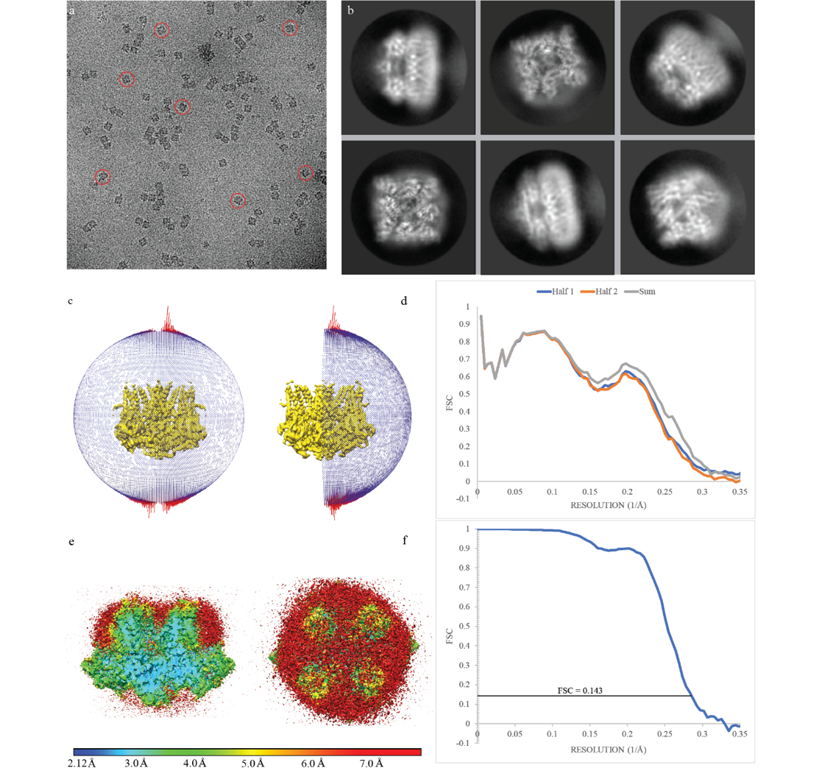

**Cryo-EM overview of crTRP1 in nanodiscs. a**, Micrograph of crTRP1 taken using a Gatan K3 DED with example particles circled in red. **b**, Reference free 2D class averages of crTRP1 in different orientations. **c**, Euler angle distribution of particles contributing to the final reconstruction; larger red cylinders represent orientations comprising more particles. **d**, FSC curves calculated between two unfiltered half-maps and the final map and a model whose coordinates were randomized and refined against only half map 1. **e**, Local resolution predicted by ResMap. **f**, FSC curve calculated between half maps.