# Temperature-sensitive TRP ion channels as Biological thermometers to gauge the pain

Thermal and pain perception is central to the survival and habitat adaptation for any form of life. More than a decade of research has been focused on understanding the molecular mechanisms underlying the intricacies of thermal perception prevailing in different species of organisms. The snakes and bats, which have special types of thermoreceptor that sense the infrared radiation for their survival and detecting the prey. These infrared detectors are essentially a class of thermoreceptors that help these two organisms to distinguish the body temperature of “homeotherm prey” from its surrounding and precisely locate their positions to orchestrate the plan for attacking them. Recent discoveries have linked the role of Transient receptor potential (TRP) channels as direct sensor of temperature and pain. TRP family of ion channel is comprised of nearly 30 members, which based on sequence homology, are categorized into the six subfamilies

Figure 1. Exemplary micrograph of TRPV1 at 37°C

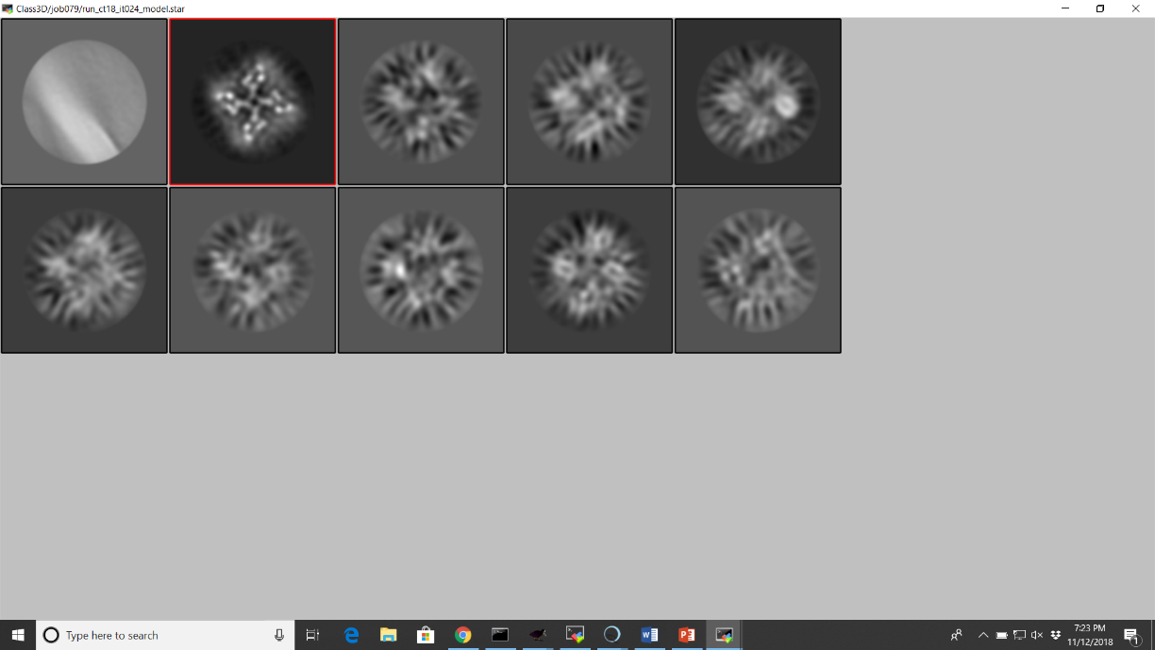To understand the conformational changes that accompanied during temperature dependence of TRPV1, this protein was pre-heated to 37C before applying to the gold side of the C-flat gold grid. The excess of liquid is removed by the applying the filter papers in vitrobot maintained at 37C, and 100% humidity. In striking contrast, the grids that were made at 42C did not show vitreous ice in the holes and accordingly not a good spread of particles. Therefore, we stick to the cryo-EM grids prepared at 37°C temperature hoping that this temperature would be enough to allows temperature mediated conformational changes in the TRPV1 channels.

Figure 2. 3D classification, the single class which was show promise for determining the structure at higher temperature.