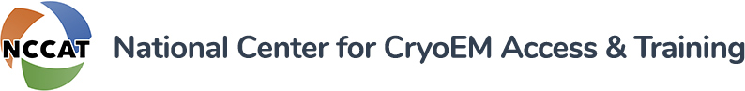

**FDNY Laboratory Requirements Form**

NCCAT is classified as a non-production chemical laboratory.

All non-production chemical laboratories require an individual holding a Certificate of Fitness for Non-Production Chemical Laboratories (C-14) to be present at all times during operation.   
  
A non-production chemical laboratory is a building or portion of a building where chemicals or gases are stored, handled or used on a non-production basis for testing, research, experimental, instructional or educational purposes.

A lab is considered to be in operation when it is open and a chemical that requires a Certificate of Fitness is being handled or used. All laboratories must be built to specifications set by the NYC Department of Buildings (DOB).

C-14 laboratory certificate of fitness training is a one-time training requirement, as long as renewals are properly maintained. C-14s that have expired may require that training be repeated. C-14 laboratory certificates of fitness may be acquired in the following ways:

* an EHS-provided C-14 training program (eligibility restrictions apply)
* an FDNY-provided C-14 program (eligibility restrictions apply)

**For more information, please contact:**

**NYC Fire Department (FDNY)**   
Public Certification Unit   
9 MetroTech Center, 1st Floor   
Brooklyn, NY 11201   
Phone: (718) 999-1988   
[pubcert@fdny.nyc.gov](mailto:pubcert@fdny.nyc.gov)

I read FDNY SOPS and understand procedures and requirements mandated by FDNY_____________________

*Initials*

Name: ___________________________________________ Date: ____________________________________

*Please Print*

Signature: ________________________________________