The collaborative spirit of the Center for Biomolecular Structure and Dynamics at The University of Montana (UM) offers numerous prospects for research based TP1 training. Below are brief details on two projects for the TP1 training that reflect the diversity of MicroED studies, ensure completion of TP1 goals, and reflect the future range of projects that the PI will be working on after TP1 training.

**Project 1: Synthetic Helical Anion Foldamers Meet Biological Anion Transport**

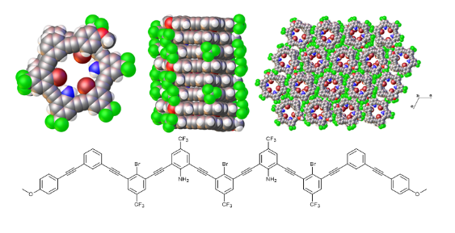The blending of small molecule supramolecular chemistry with biological anion transport represents the intersection of two seemingly different fields. Research at discipline crossroads, such as this, often present unique approaches to chemical and biochemical problems. The Berryman lab at UM is expanding into the field of synthetic anion transport by further developing their established helical assemblies.1,2 Specifically they have synthesized a family of oligomers up to 15 repeat units with systematically varied substituents (example shown in Figure 1). Solution studies have indicated different speciation based on oligomer variant and when introduced to different anions. Structural elucidation will better inform the solution and dynamics data gathered from anion transport assays and binding studies. However, crystallization of these species is notoriously difficult—only 1 structure of an m-arylene-ethynylene oligomer is contained within the Cambridge Structural Database. The herculean effort (over 2 years) of the Berryman lab has only produced a single X-ray structure—a species with nine repeat units (Figure 1). However, crystallization of both the oligomer and oligomer—anion complex often produce material too small for traditional X-ray diffraction studies, making them promising candidates for MicroED.

Figure 1. 9-mer helicate single strand (top left), single helical column (top middle), packing (top right). Bottom chemdraw highlights the composition of the 9-mer. Extended oligomers contain additional bromine and/or amine containing rings.

**Project 2: Ric-8A—A unique guanine nucleotide exchange factor**

Heterotrimeric G proteins (comprised of α, β, and γ subunits) regulate various cellular functions by the exchange of GDP and GTP. The release of GDP from Gα can be facilitated by additional proteins, several of which have been identified in the cytoplasm. Resistance to Inhibitors of Cholinesterase 8A (Ric-8A) is one of these proteins and facilitates the release of GDP different than other guanine nucleotide exchange factors. This, along with the fact that Ric-8A is also a Gα chaperone, has motivated inquiries into its mechanism, and until recently structural details remained scarce.

In 2019, the Sprang lab at the UM elucidated the structure of Ric-8A 1-452 though X-ray crystallographic studies.3 This was followed by X-ray crystal structures of the apo form of Ric-8A 1-492 and a complex of Ric-8A 1-426 with a tagged C-terminal peptide of Gα.4 In 2020, the Sprang lab reported the X-ray crystal structure and the cryoEM structure of nanobody stabilized Ric-8A 1-491 bound to Gαi1.5 Since this study there have been several other CryoEM structures that have elucidated folding intermediates of the Ric-8A with Gαi and Gαq highlighting the interest in this area.6

A MicroED structure of Ric-8A bound to Gαi1 would provide an ideal TP1 training data set as the X-ray and CryoEM structures are known, the materials are readily available, and methodology for crystallization has been established. This work would also provide a tangible example of the interplay between data quality differences between these three techniques using a modern research sample, not lysozyme. Ongoing studies of mutated Ric-8A in the Sprang lab are expected to produce similar crystalline materials suitable for MicroED. Other considerations for the TP1 training under this project include the native 530-amino structure of Ric-8A as well as the homologue Ric-8B—both of which remain elusive and produce microcrystalline material.

**Overall, these projects represent a blend known and novel works that will ensure the training goals of TP1 are met, produce meaningful results, and grow the appreciation of MicroED.**