SPA processing workflow

Goals & Objectives
- Become acquainted with the general SPA processing workflow by performing common processing tasks in cryoSPARC v4.4.1.
- Become acquainted with the cryoSPARC GUI and understand how it is used to perform key steps in SPA processing.
- In part 1, you will process a 200-micrograph dataset from movie alignment to 3D reconstruction. This is meant to simulate a small dataset one might obtain from a screening session. The goal is to assess micrograph and particle quality to determine whether a grid should go to large-scale data collection.
- In part 2, you will assess the conformational and compositional heterogeneity within a particle stack using 3D refinement and 3D classification tools. You will generate a clean consensus refinement at high resolution (Part 2A) and then assess conformational heterogeneity within that clean consensus particle stack (Part 2B).

System requirements
- Computer connected to an NYSBC Wi-Fi network and web browser (Chrome is preferred)
- Chimera – download and install from here (https://www.cgl.ucsf.edu/chimera/)
  - ChimeraX is a good alternative, but I cannot provide support as many commands and buttons are different from Chimera

Additional Resources
The cryoSPARC Guide serves as an excellent resource for in-depth descriptions of each job type. https://guide.cryosparc.com/processing-data/get-started-with-cryosparc-introductory-tutorial

The cryoSPARC Discussion Forum is an excellent community for troubleshooting, feature requests, and discussion of future developments. If you have a question that can’t be answered by the cryoSPARC Guide, this is the next place to check. It’s also a good place to search for solutions to specific error messages.
https://discuss.cryosparc.com/

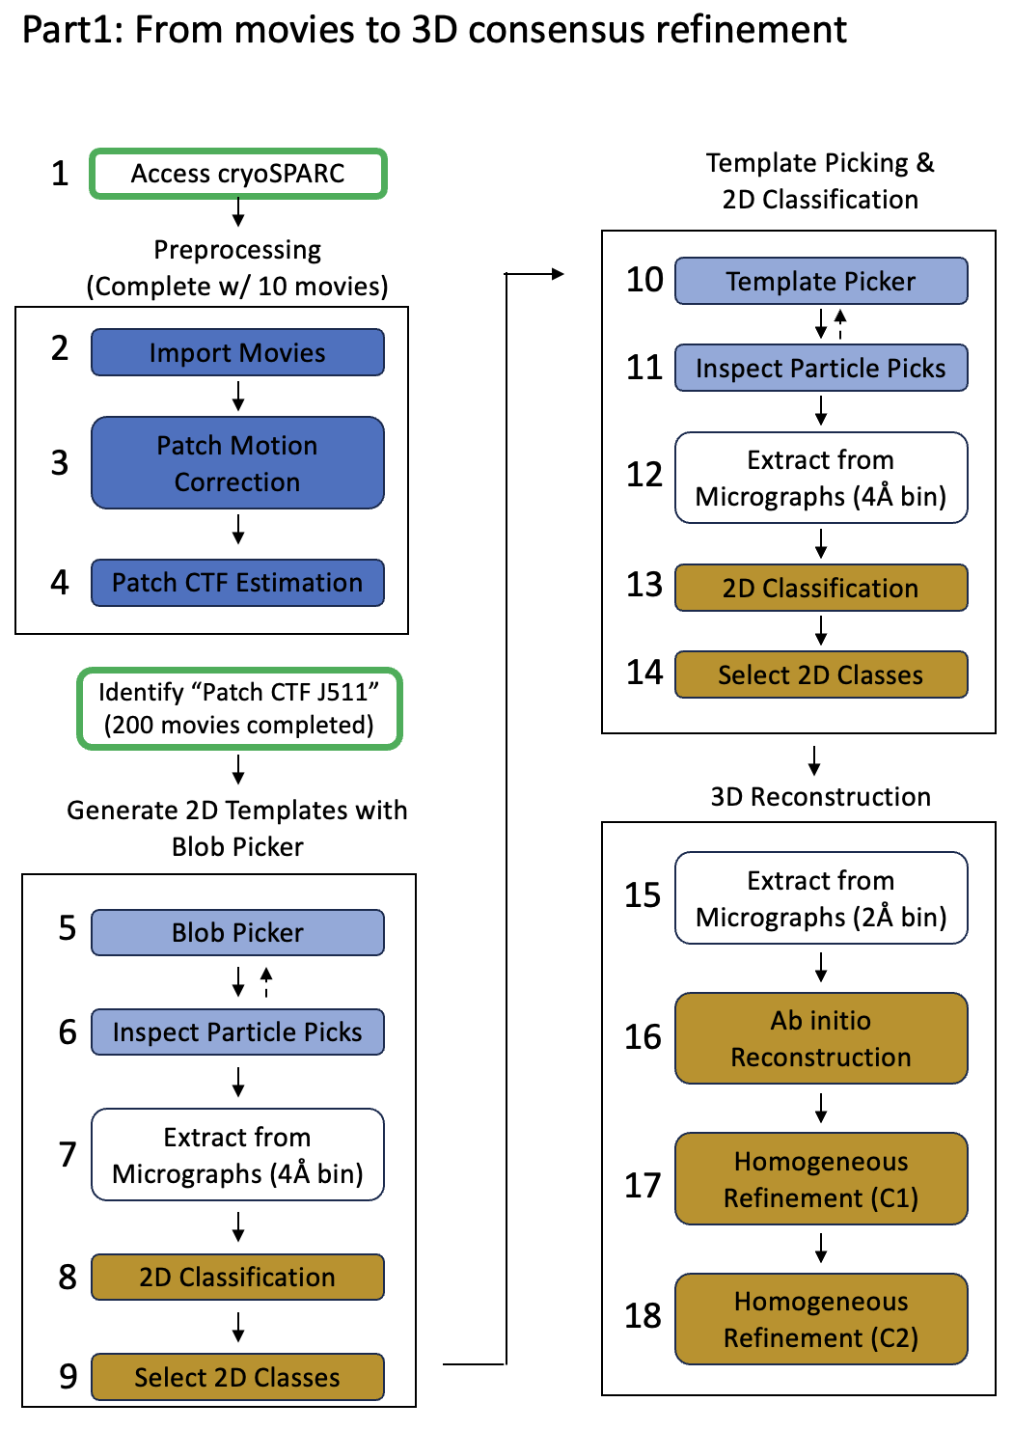
Accessing a Project and Workspace
Background : The organizational hierarchy in cryoSPARC is Project -> Workspace -> Job.
- Projects are often used for different users, samples, or biological systems.
- Workspaces are often used for separate datasets. Each project can contain multiple workspaces
- Jobs are the basic processing operations of cryoSPARC and must be performed within a specific workspace. You can link jobs between workspaces, but you cannot link jobs between projects.

- Step 1 – System setup, accessing cryoSPARC and navigating to your workspace.
  - 1.1 - Be at NYSBC on the Wi-Fi. In your web browser, enter:
    - http://cryosparc6.semc.nysbc.org:39000/
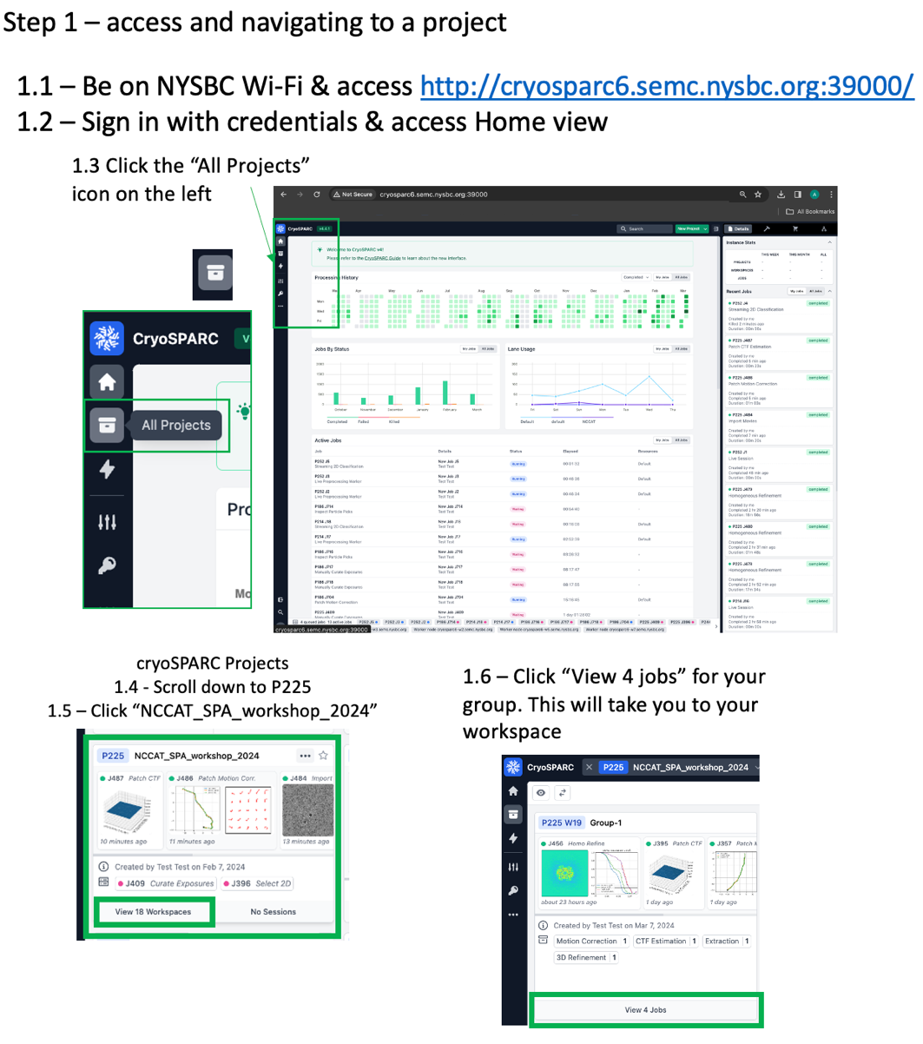
  - 1.2 - Sign in with the following information:
    - Email: test@test.test
    - Password: testtest
  - 1.3 – Click the “All projects” icon in the top left. It looks like a file box.
    - Now you can see all the projects. These are different users’ imaging sessions.
    - Please stay within the specified session for today (P225).
  - 1.4 - Scroll down to P225 NCCAT_SPA_workshop_2024 and click “View # Workspaces”
  - 1.5 - Click on the “View # Jobs” button at the bottom of the workspace for your group#
  - 1.6 – Find your group # and click “View 4 jobs” at the bottom

Movie Preprocessing
You will import 10 movies (step 2) and run patch motion correction (step 3) and patch CTF estimation (step 4). You will then locate a completed Patch CTF Estimation job (J511) containing 200 micrographs that have undergone the same process and proceed to Blob Picker (step 5).

“Import Movies” job directs cryoSPARC to the location of movies on the working drive/database. This job also imports the gain file and requires input of data collection parameters (pixel size, spherical aberration, total dose, accelerating voltage). The Event Log will display unaligned summed frames that may appear streaky due to motion.

“Patch motion correction” aligns the raw movie frames in patches and applies gain correction. Patch motion correction creates diagnostic plots indicating the rigid motion trajectory and local trajectory for each patch. These aligned micrographs will used for downstream jobs (patch CTF estimation, particle picking, and particle extraction).

“Patch CTF estimation” attempts to determine the defocus of aligned micrographs generated by Patch motion correction, and will measure additional parameters that vary from one micrograph to another; astigmatism, estimated resolution, and others.

You could import aligned micrographs generated from other software and directly run patch CTF estimation, skipping cryoSPARC’s motion correction. This is helpful if you have run motion correction in a separate software or have transferred aligned micrographs generated during collection at a facility (e.g. *enn-a-DW.mrc files generated by motioncor2).
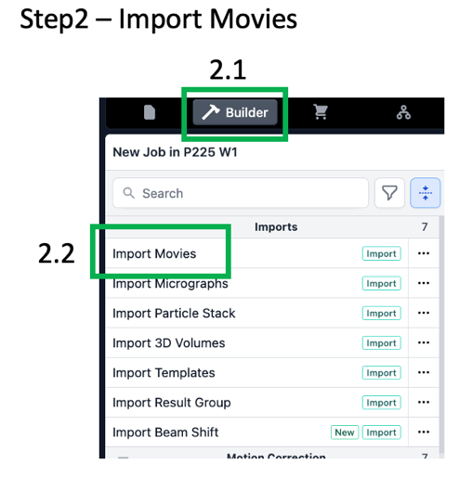
Import Movies
- Step 2 - Import movies to cryoSPARC
  - 2.1 – Click “Builder” button
  - 2.2 – Click “Import Movies” at the top. A new job is built and you should have access to the “Details” and “Parameters” pages on the right.
  - 2.3 – Select Movies data path
    - click the folder icon for Movies data path & the Select movies data path page opens. From here you can navigate directories to point cryoSPARC to your movies. Copy and paste the following path into the directory bar at the top /h3/nworkshop/SPA_2024/data/18feb21c/rawdata/18feb21c_b_00028gr_00003sq_v01_00002hl16_*.frames.mrc
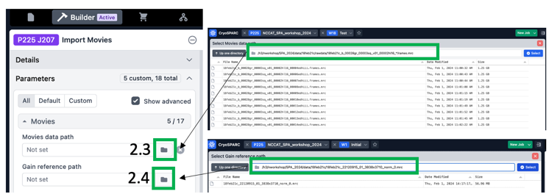
    - If this is done correctly, cryoSPARC should list the files. Ensure the files match the wildcard used. Sometimes multiple grids are present in a frames folder from a single microscope session and you must alter the wildcard to only include a single grid.
    - If it says, “Error, path must be an absolute path” then double check you entered it correctly.
  - 2.4 – Select Gain reference path – Copy the following path: /h3/nworkshop/SPA_2024/data/small_subset/references/18feb21c_22120915_01_3838x3710_norm_0.mrc
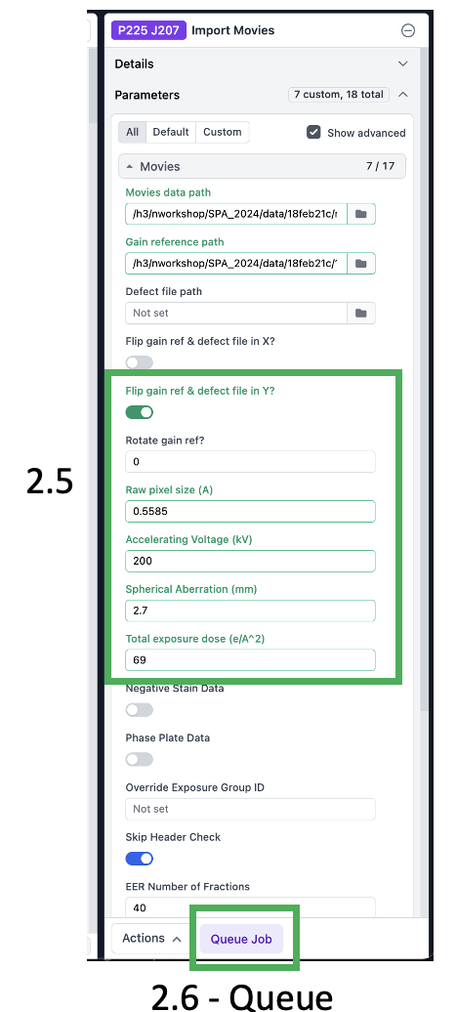
  - 2.5 – Set parameters
    - Flip gain ref and defect file in Y: ON
    - Raw pixel size (Å): 0.5585
    - Accelerating voltage (kV): 200
    - Spherical aberration (mm): 2.7
    - Total exposure dose (e-/Å2): 69
    - All others set to default. The text for parameters that have been changed from default turns green.
  - A note about gain reference flipping and rotation. Different microscopes may produce gain reference that require different rotation or flipping – do not rely on a default rule of thumb as things can change as microscopes get upgraded. You can always ask your microscope operator if the gain reference needs to be flipped. You can also test the effects of flipping and rotation. When the gain is not properly applied, there will often be visible streaky artefacts in the gain-corrected image. View the effects of improper and proper gain-correction in jobs P225-W2 - J97, J98, and J99, J100, and J101. It is quicker to run on a single micrograph or small subset than the full batch. The results are not always this obvious, so it can be helpful to view all the options in a PowerPoint slide together.

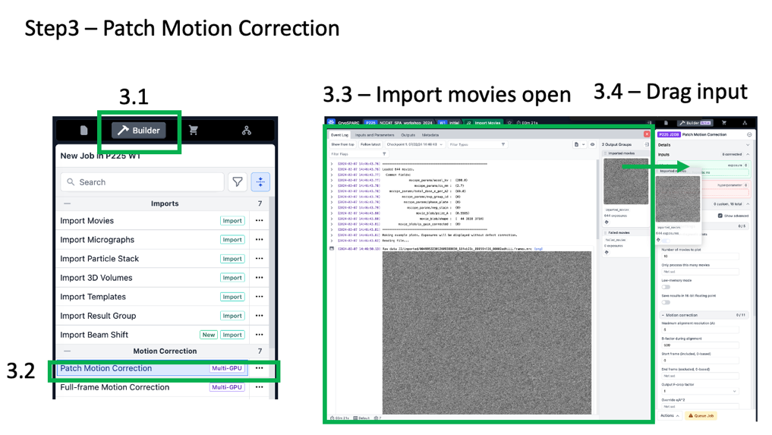
Patch Motion Correction
- Step 3 – generate aligned micrographs
  - 3.1 – Click builder button
  - 3.2 – Click “Patch motion correction” job & a new job is built
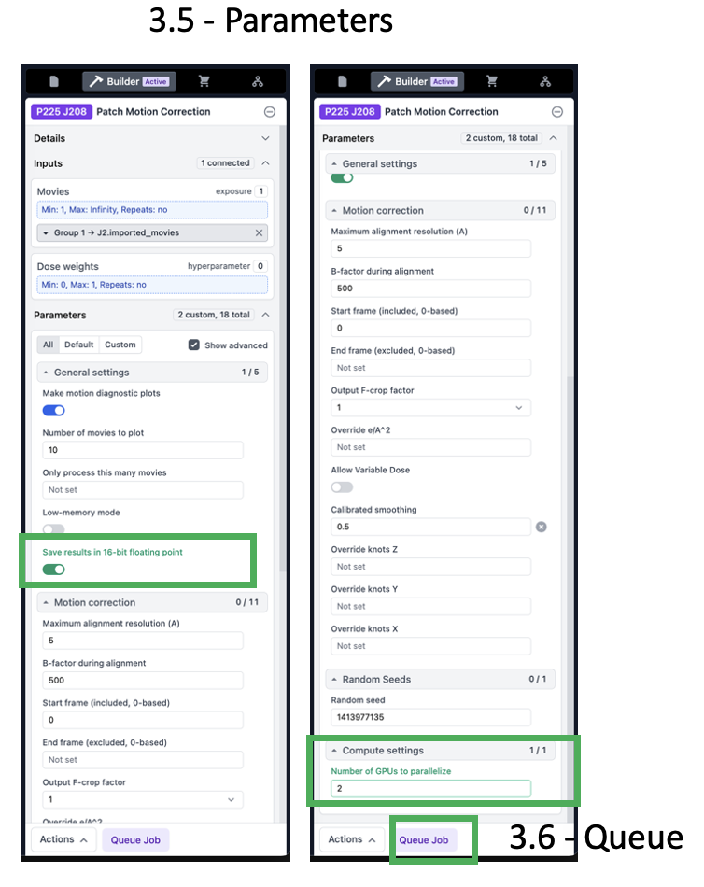
  - 3.3 - Open the previously run Import Movies job (or exposure sets job) by clicking it and hitting the space bar on your keyboard – it should open. Alternatively, click the “four-corners square box” at the top of the job, to the right of “J## Import Micrographs” (this button is only visible once you hover the cursor over the job).
  - 3.4 – Drag “Imported movies” from the right side “2 output groups” section to the “inputs” Micrographs section of the Patch Motion Correction job builder.
  - 3.5 – Parameters:
    - Save results in 16-bit floating point: ON
    - Output F-crop factor: ½ (This is the amount of binning to apply. The movies were collected at a pixel size of ~0.56Å, so Nyquist would be 1.12 Å without binning. We will bin by a factor of 2 so our aligned micrographs have a pixel size of 1.12 Å and Nyquist will be 2.24 Å. If refinements start to get close to this 2.24 Å, we can repeat this step with F-crop factor of 1, or no binning, to try to get higher resolution.
    - Number of GPUs to parallelize: 2 (or more if available)
  - 3.6 – Click Queue, Choose NCCAT lane and Queue

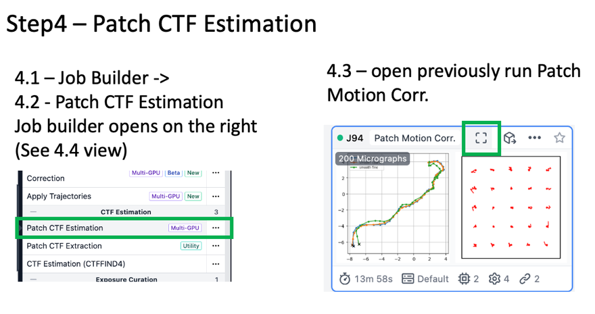
Patch CTF Estimation
- Step 4 – Estimate the defocus for each micrograph
  - 4.1 – Click “Builder” button &
  - 4.2 – Click “Patch CTF Estimation” and the job builder opens
  - 4.3 – Open the previously run Patch Motion Correction job by clicking it and hitting the space bar on your keyboard – it should open. Alternatively, click the “four-corners square box” at the top of the job, to the right of “J## Patch Motion Corr.” (this button is only visible once you hover the cursor over the job).
  - 4.4 – Drag “Micrographs” from the right side “2 output groups” section to the “inputs” Micrographs section of the Patch CTF Estimation job builder.
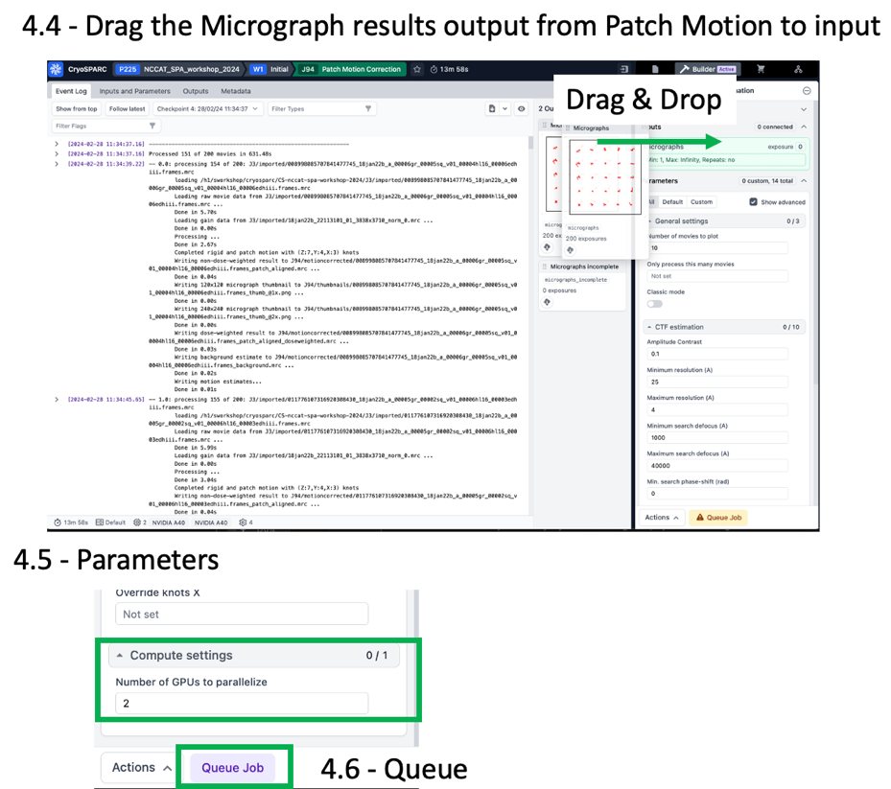
  - 4.5 – Parameters – Only change the Compute Setting “Number of GPUs to parallelize” to 2 (from default of 1).
  - 4.6 – Queue Job on NCCAT lane
  - Monitor diagnostic plots
    - 2D patch result visualizes the defocus across the whole micrograph. If you have a tilted sample, this should be tilted. If there are large features, like gold or carbon foil on the edge, large debris, or a very obvious ice gradient, these can often be visualized on this graph.

Blob-based particle picking & Inspect Picks
Particle picking
There are various strategies for particle picking. When getting started on a new dataset, the shape and size of a particle may be unknown. Blob picker can be used to obtain initial particle picks, which will be extracted and 2D classified. The resulting 2D classes can be used as templates for Template Picking, which can be more accurate than Blob Picker.

Inspect picks
Particle picking parameters often cannot be tuned to perfectly exclude off-target (non-protein) picks. The inspect particle picks job allows one to assess the quality of particle picks before proceeding to extraction and 2D classification. It also includes a filtering tool to remove particle picks based on a scoring system. We will use the filtering tool sliders to set thresholds (3 sliders to optimize) to exclude as many off-target non-protein picks as possible, while maintaining as many on-target picks as possible.
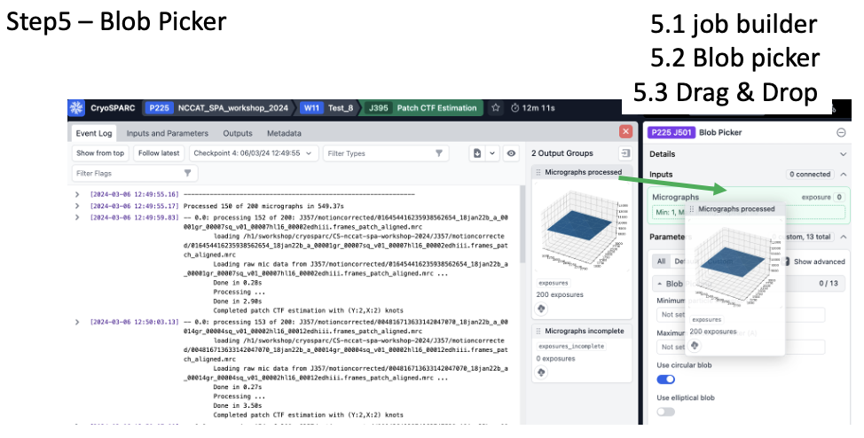
While 2D classification is useful to remove junk, removing as much junk as possible early on can give better results and an overall cleaner particle stack in the end.

- Step 5 - Run Blob Picker
  - 5.1 - Click “Builder” button & then click “Blob Picker” & details and parameters pane opens
  - 5.2 - Open the previously run “Patch CTF Estimation” job (J511) so the output groups are accessible
  - 5.3 – Drag “Micrographs Processed” into the Blob Picker input “Micrographs”
  - 5.4 - Parameters:
    - Minimum particle diameter (Å): 50
    - Maximum particle diameter (Å): 70
    - Use circular blob: ON
    - Use elliptical blob: ON
    - Minimum separation distance: 1 (large effect on tuning)
    - Not necessary to change other parameters
  - 5.5 - QUEUE JOB
  - Compute considerations – this job can only use 1 GPU (no parallelization option)
  - 5.6 – As the job runs, you can follow progress in the event log and see the red dot blob picks for each micrograph. Once the first 10 micrographs have completed, it will stop showing diagnostic plots. You can re-visit these by clicking “show from top” to go see the first 10 micrograph particle picks. You can also see the shape and size of the circular and elliptical blobs that were generated for picking.

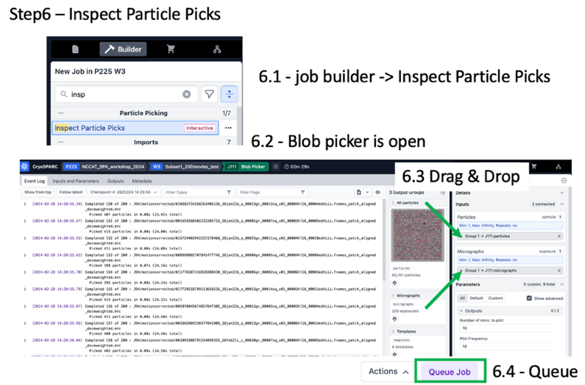
- Step 6 – Inspect particle picks
  - 6.1 - Click “Builder” button & then click “Inspect particle picks” & the details and parameters pane opens
  - 6.2 - Open the previously run “Blob Picker” job so the output groups are accessible
  - 6.3 – Drag “All particles” from the completed blob picker job into the inspect picks “Particles” input and drag “Micrographs” into the Micrographs input.
  - 6.4 – Queue – this job is interactive
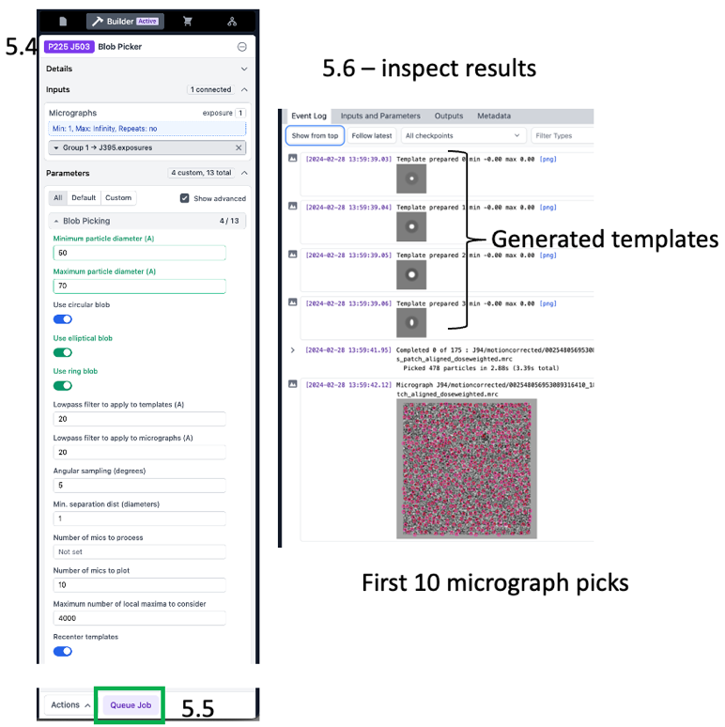
  - 6.5 - The green circles depicting particle picks can get in the way of viewing the micrograph. Drag the “Particle diameter” slider to ~15 Å to put a small green circle on each particle pick.
  - 6.6 – click through the micrographs. You can sort them by number of picks, CTF estimated resolution, or other parameters
  - 6.7 – Drag the NCC score slider to the right and observe how many off-target picks are removed. Optimize this over 5 to 10 micrographs to remove off-target picks while maintaining on-target picks.
  - 6.8 – Adjust the power histogram sliders. Optimize this over 5 to 10 micrographs to remove off-target picks while maintaining on-target picks.
  - 6.9 - Click “Done Picking | Output Locations” in the top right
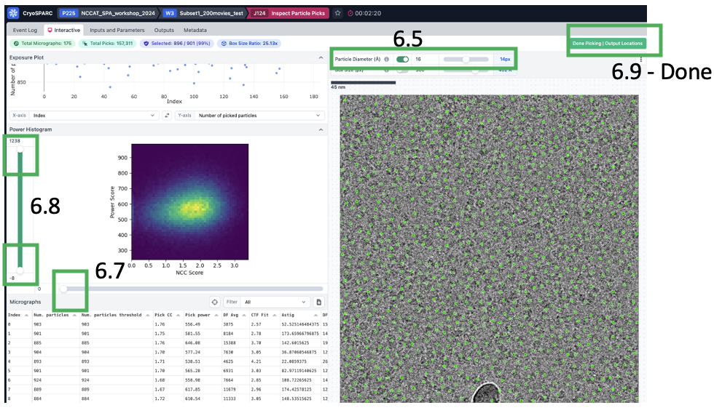
- Iterate Step 5 and Step 6 until results are acceptable. It is better to overpick than to underpick, because you can filter out many off-target picks with 2D classification, but unpicked particles must be recovered by some particle picking mechanism or they will remain unused.

Particle Extraction
Extract From Micrographs (GPU)
This job generates a “particle stack” or a collection of images with specified box size taken from the micrograph. Key parameters to take into consideration are the extraction box size and the amount of binning (fourier cropping) to apply. cryoSPARC has different job types for GPU-based extraction or CPU-based extraction and their output particle stacks will be the same.

Determining an appropriate box size
Generally, choose a box size that is 2.5-3x larger than the longest particle dimension. If your particle is 50 x 50 x 70 Å, we would use a box size of 70 x 2.5 = 176 Å. The box size input parameter is in pixels, so convert 176 Å to pixels (175 Å / 1.12 Å/pix = 156.25 pixels). Round to 156, since box size must be an even integer.
We can iteratively optimize this based on the 2D classification results, which can be helpful if we miscalculate or have unexpected features. For example, when particles are very close together, we might want a somewhat smaller box to exclude neighboring particles.

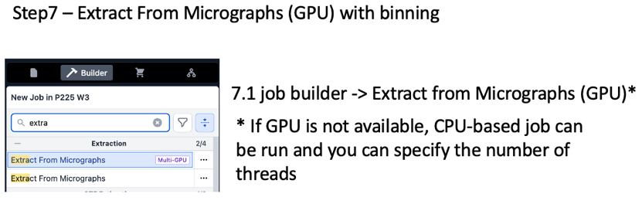
Calculate the binning (fourier crop) as follows:
Mic pixel size (Å/pix) x Extract box size (pix) = fourier crop box size (pix) x bin pixel size (Å/pix)
let’s say we want to extract in a box of 176 pixels and bin to 4 Å. Calculate the fourier crop box size.
1.12 Å/pix x 176 pix = 4 Å/pix x fourier crop box size
197.12 / 4 = 49.28 pixels
The box size must be an even integer, so choose 50 as fourier crop box size. We did some rounding, so what’s the actual binned pixel size?
1.12 Å/pix x 176 pix = binned pixel size Å x 50 pix
1.12 x 176 / 50 = 3.9424 Å/pix = binned pixel size

- Step 7 – Extract From Micrographs (GPU) with binning
  - 7.1 - Click “Builder” button & then click “Extract” & the details and parameters pane opens
  - 7.2 - Open the previously run “Particle Inspection” job so the output groups are accessible
  - 7.3 – Drag “All particles” from the completed blob picker job into the inspect picks “Accepted Particles” input and drag “Micrographs” into the Micrographs input.
  - 7.4 – Parameters
    - Extraction box size (pix): 176
    - Fourier Crop to box size (pix): 50
    - Save results in 16-bit floating point: ON
  - 7.5 Queue job
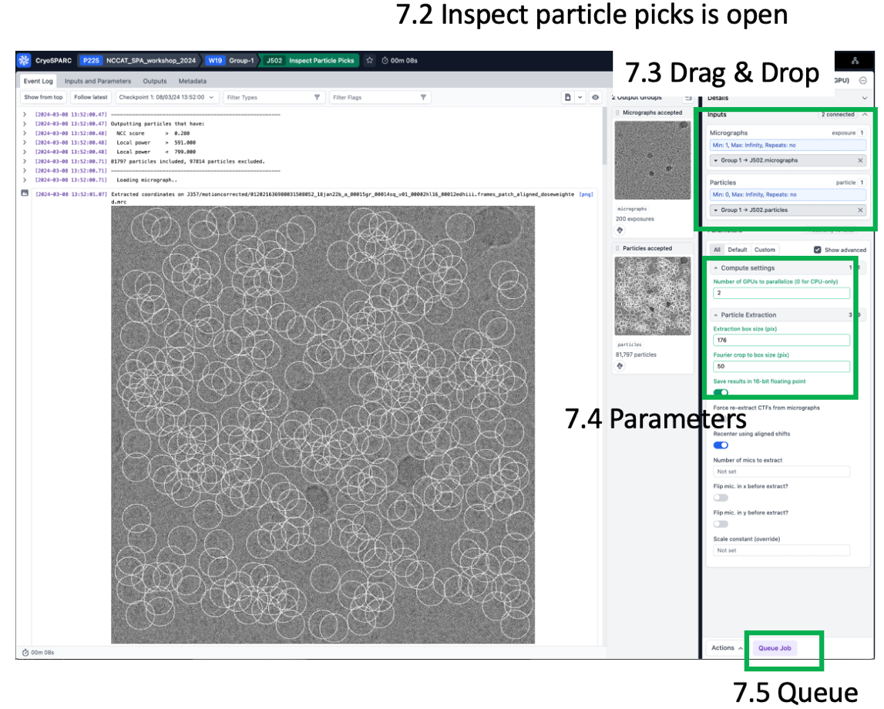

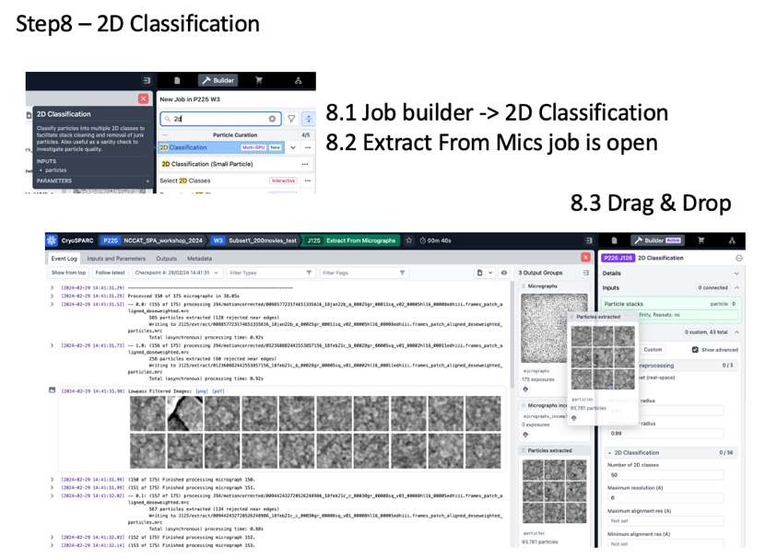
- Step 8 – 2D Classification
  - 8.1 - Click “Builder” button & then click “2D Classification” & the details and parameters pane opens
  - 8.2 - Open the previously run “Extract From Micrographs” job so the output groups are accessible
  - 8.3 – Drag the “Particles Extracted” from the completed Extract from Micrographs job into the 2D Classification “Particle Stacks” input
  - 8.4 – Parameters
    - Number of 2D classes: 100
    - Number of GPUs to parallelize: 2
  - 8.5 Queue Job
    - The job runs in 5-10 minutes for 100 classes with ~100k particles binned in a ~50 pixel box.
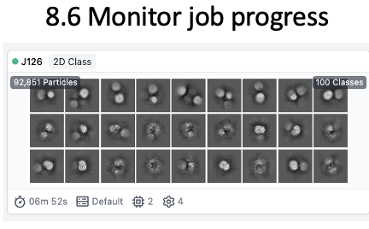

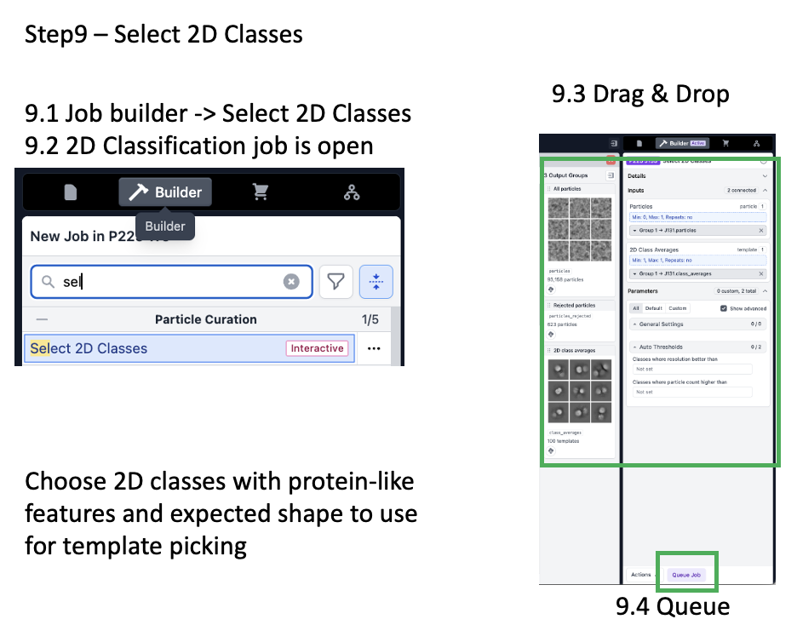
- Step 9 – Select 2D Classes
  - 9.1 - Click “Builder” button & then click “2D Classification” & the details and parameters pane opens
  - 9.2 - Open the previously run “Extract From Micrographs” job so the output groups are accessible
  - 9.3 – Drag the “Particles Extracted” from the completed Extract from Micrographs
  - 9.4 – Queue job – this job is interactive, wait for the “wait” step (it will turn pink)
  - 9.5 - Select classes of interest
  - 9.6 - Click “Done”

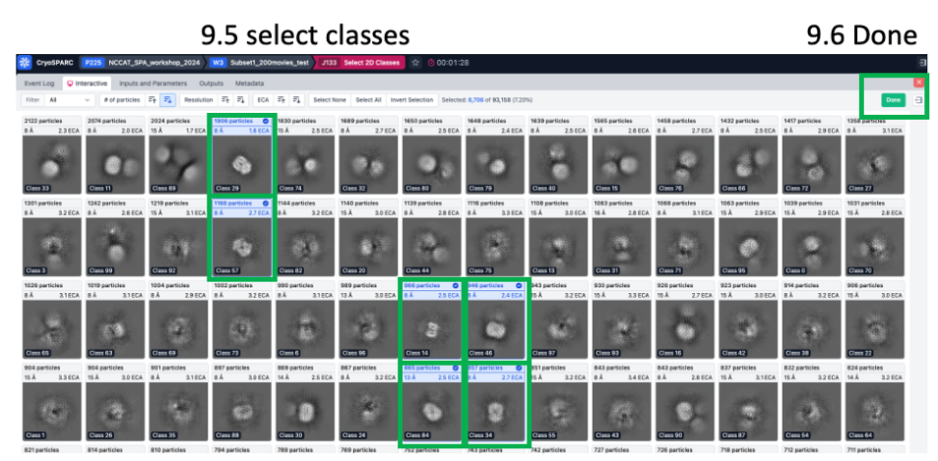

Template Picker, Extraction, & 2D Classification

Template Picker
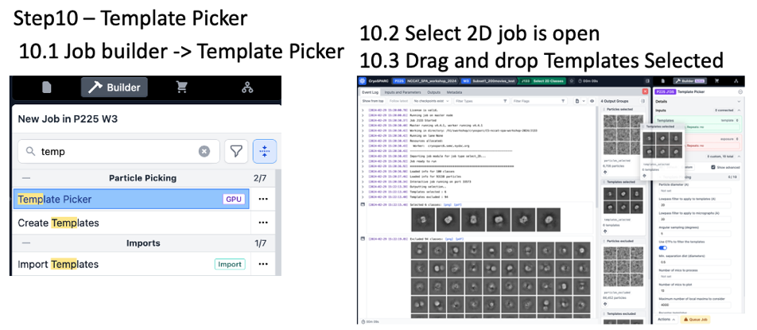
Now you have 2D classes that we can use as templates for template-based particle picking. Hopefully, template-based particle picking will give more on-target protein picks and increase the number of high-quality particles. These particle picks should also be better centered than blob-based particle picks. We will run template picker and optimize parameters with the same subset of micrographs selected in step 4b (or simply use all micrographs because this dataset processes fast).

Extraction
Again, we will extract with binning for the particles that will be used for 2D classification.

2D classification

- Step 10 – Template Picker
  - 10.1 - Click “Builder” button & then click “Template Picker” & the details and parameters pane opens
  - 10.2 - Open the previously run “Select 2D Classes” job so the output groups are accessible
  - 10.3 – Drag the “Templates Selected” output from the completed “Select 2D Classes” job and drag it to the Templates input in the Template Picker builder
  - 10.4 – Open the previously run Patch CTF job
  - 10.5 - Drag the “Micrographs Processed” output from the completed “Patch CTF” job and drag it to the Micrographs input in the Template Picker builder
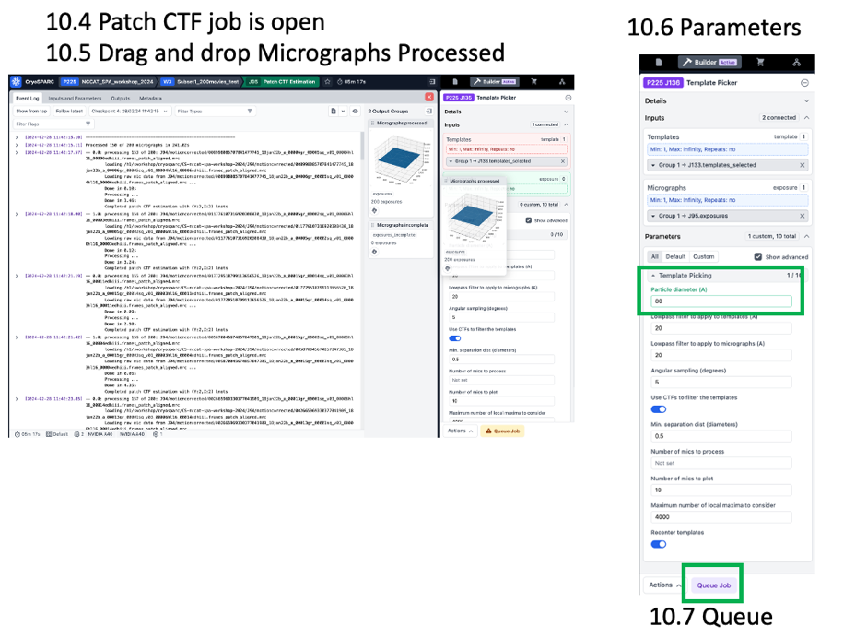
  - 10.6 – Parameters
    - Particle diameter (Å): 80
    - Min. separation dist (diameters): 0.5
  - 10.7 - Queue
  - 10.8 – follow the progress, click show from top and view the first 10 micrographs, as well as the low-pass filtered templates used for picking.
  - Compute considerations – this job requires 1 GPU and cannot be parallelized

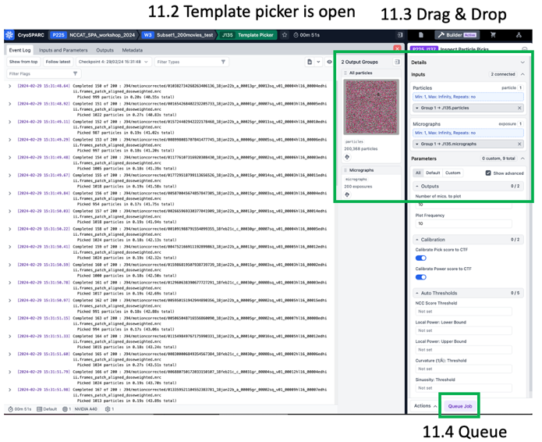
- Step 11 – Inspect particle picks
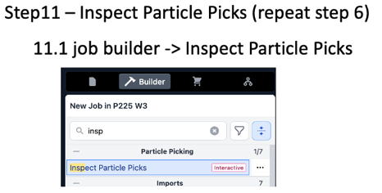
  - 11.1 - Click “Builder” button & then click “Inspect particle picks” & the details and parameters pane opens
  - 11.2 - Open the previously run “Blob Picker” job so the output groups are accessible
  - 11.3 – Drag “All particles” from the completed blob picker job into the inspect picks “Particles” input and drag “Micrographs” into the Micrographs input.
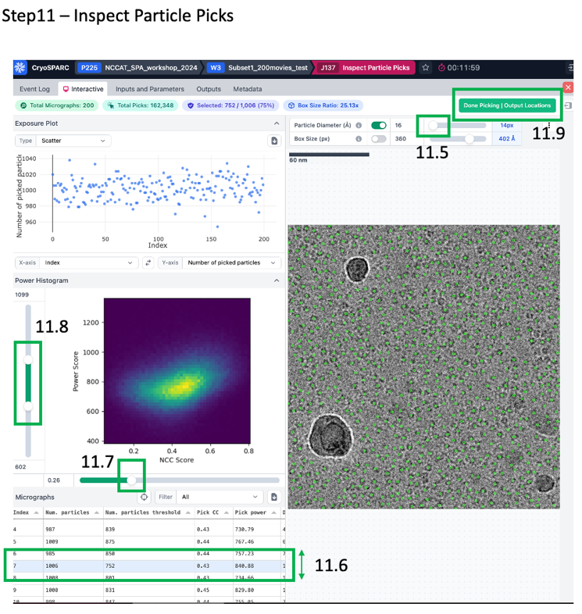
  - 11.4 – Queue – this job is interactive
  - 11.5 - The green circles depicting particle picks can get in the way of viewing the micrograph. Drag the “Particle diameter” slider to ~15 Å to put a small green circle on each particle pick.
  - 11.6 – click through the micrographs. You can sort them by number of picks, ctf estimated resolution, or other parameter
  - 11.7 – Drag the NCC score slider to the right and observe how many off-target picks are removed. Optimize this over 5 to 10 micrographs to remove off-target picks while maintaining on-target picks.
  - 11.8 – Adjust the power histogram sliders. Optimize this over 5 to 10 micrographs to remove off-target picks while maintaining on-target picks.
  - 11.9 - Click “Done Picking | Output Locations” in the top right

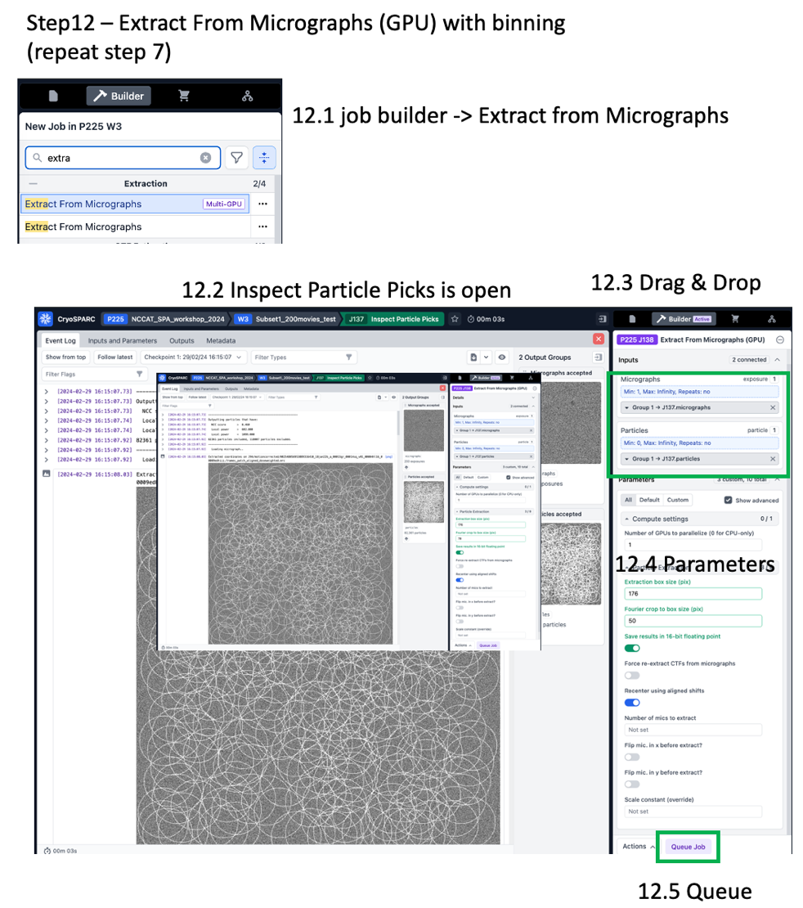
- Step 12 – Extract with binning
  - 12.1 - Click “Builder” button & then click “Extract From Micrographs” & the details and parameters pane opens
  - 12.2 - Open the previously run “Particle Inspection” job so the output groups are accessible
  - 12.3 – Drag “All particles” from the completed blob picker job into the inspect picks “Accepted Particles” input and drag “Micrographs” into the Micrographs input.
  - 12.4 – Parameters
    - Number of GPUs to parallelize: 2
    - Extraction box size (pix): 176
    - Fourier crop to box size (pix): 50
    - Save results in 16-bit floating point: ON (saves space)
  - 12.5 Queue job

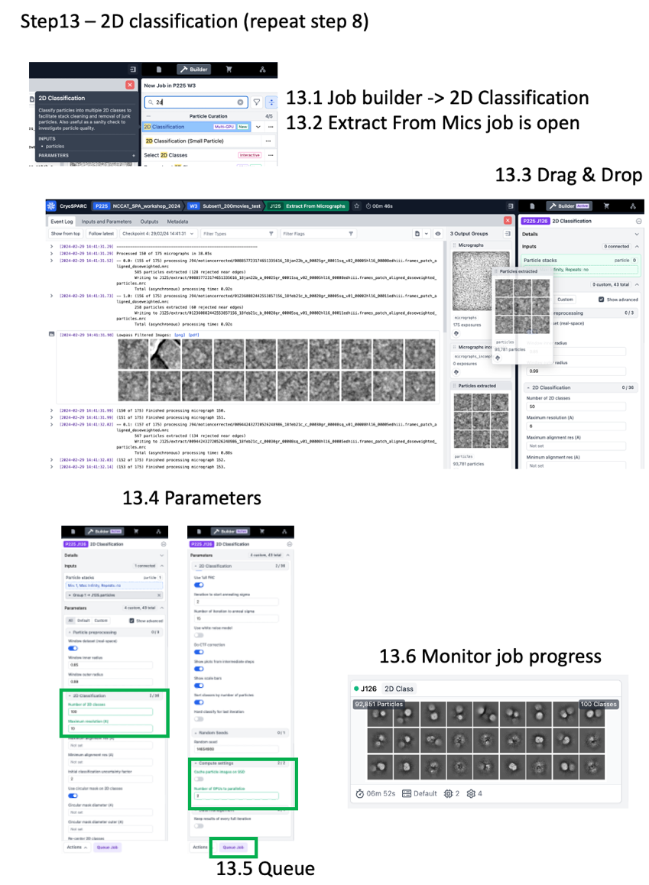
- Step 13 – 2D Classification (repeat Step 8 with the same settings)
  - 13.1 - Click “Builder” button & then click “2D Classification” & the details and parameters pane opens
  - 13.2 - Open the previously run “Extract From Micrographs” job so the output groups are accessible
  - 13.3 – Drag the “Particles Extracted” from the completed Extract from Micrographs job into the 2D Classification “Particle Stacks” input
  - 13.4 – Parameters
    - Number of 2D classes: 100
    - Number of GPUs to parallelize: 2
    - Cache particles to SSD: OFF
  - 13.5 Queue Job
    - The job runs in 5-10 minutes for 100 classes with ~100k particles binned in a ~50 pixel box.

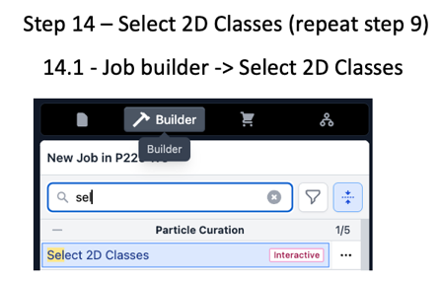
- Step 14 – Select 2D Classes
  - 14.1 - Click “Builder” button & then click “2D Classification” & the details and parameters pane opens
  - 14.2 - Open the previously run “Extract From Micrographs” job so the output groups are accessible
  - 14.3 – Drag the “Particles Extracted” from the completed Extract from Micrographs
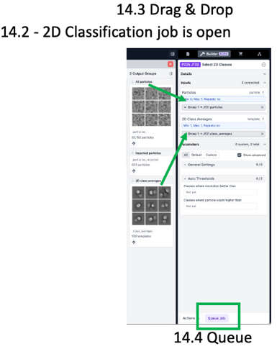
  - 14.4 – Queue job – this job is interactive, wait for the “wait” step (it will turn pink)
  - 14.5 - Select classes of interest
  - 14.6 - Click Done
  - This can be the final particle stack or you can run another select job followed by another round of 2D classification.
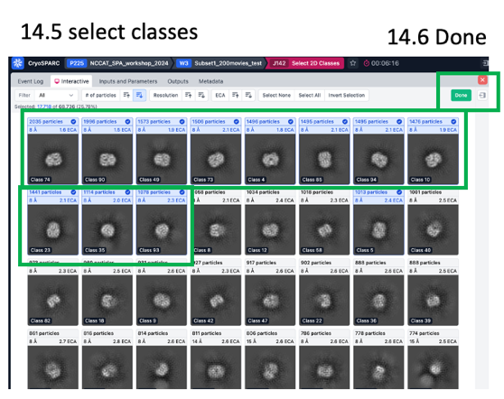

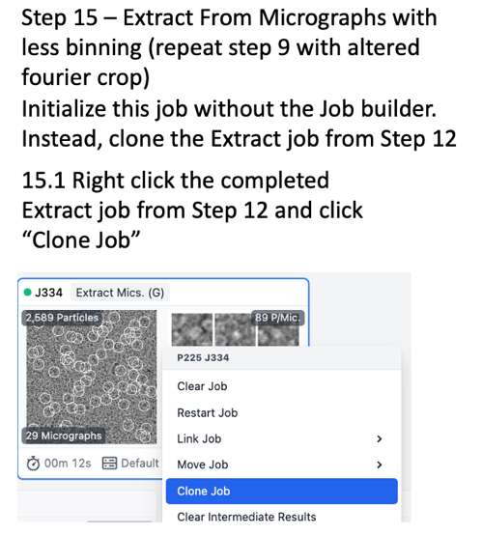
Extract with less binning, run Ab initio reconstruction, and generate initial 3D reconstruction
Assuming you now have a relatively clean particle stack, it is time to generate a 3D reconstruction. The particles selected in step 14 are binned to 3.9 Å, so Nyquist resolution is 7.8 Å. For a screening dataset, this is likely sufficient to give the general particle shape and inform on whether the expected particle is present. Depending on your needs, you might want higher resolution. Let’s extract with less binning to see how good the resolution can get with 1/8th of the original dataset and bin (fourier crop) to 132 pixels. The binned pixel size for this particle stack is calculated as follows:
176 extraction box size x 1.12 Å/px / 132 px fourier crop box size = 1.493 Å binned pixel size,
so Nyquist will be 3.0 Å for this particle stack.

- Step 15 (Optional, applicable for higher resolution datasets) – Extract from Micrographs with less binning
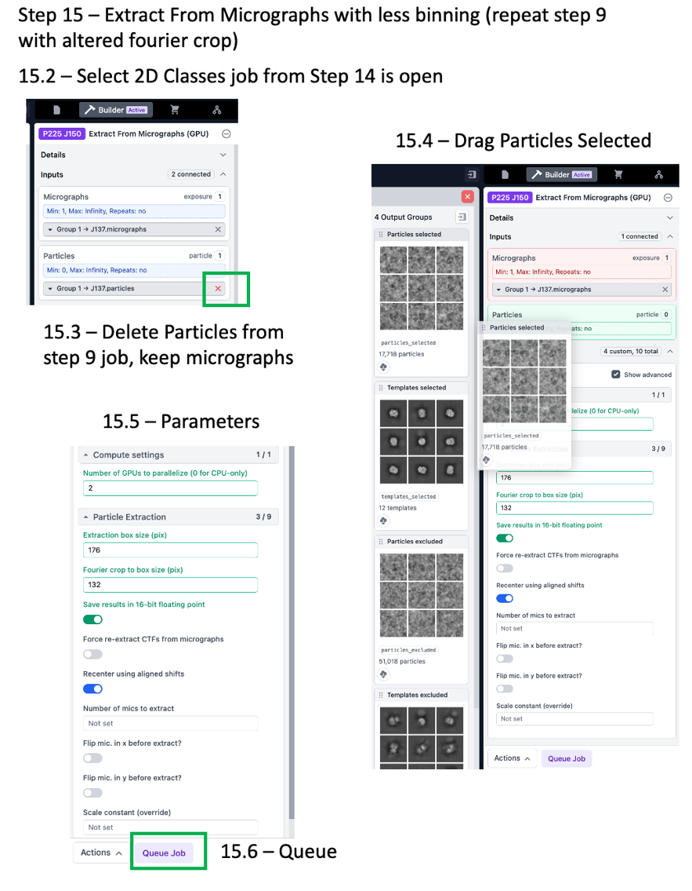
  - 15.1 - Initialize this job by cloning the previously run Extract job. Right click the Extract job from Step 13 and click “Clone Job” & the details and parameters pane opens for the newly built job
  - 15.2 - Open the previously run “Select 2D Classes” job so the output groups are accessible
  - 15.3 – Delete the “particles selected” from Step 14 to the input
  - 15.4 - Drag “All particles” from the completed Select 2D Classes job into the Extract From Micrographs “Particles” input. The same micrographs from the previous Extract job can be kept.
  - 15.5 – Parameters
    - Number of GPUs to parallelize: 2
    - Extraction box size (pix): 176
    - Fourier crop to box size (pix): 132
    - Save results in 16-bit floating point: ON (saves space)
  - 15.6 Queue job
  - This job ran in ~1min using 2 GPU when extracting ~70k particles from 200 micrographs with binning from 176 to 132 pixels.

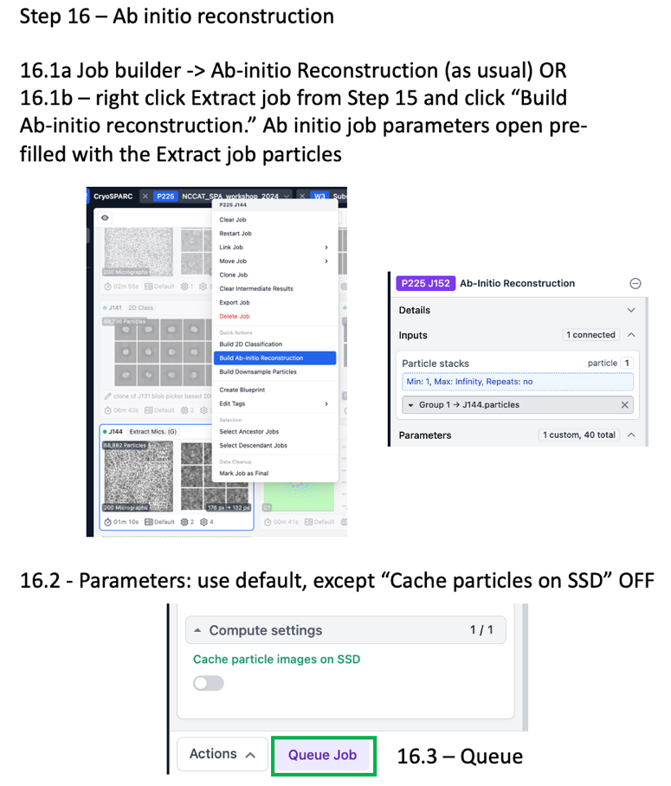
Generate consensus refinement

- Step 16 – Ab Initio reconstruction
  - 16.1a – Use the job builder to create the job and drag the particles from Step 15 as input OR
  - 16.1b – Right click the Extract job from Step 15 and click “Build Ab-initio reconstruction” to automatically populate the newly built job with the Extract particle output
  - 16.2 - Parameters:
    - All default, except
    - Cache particle images on SSD: OFF

- Step 17 – Homogeneous Refinement
  - 17.1a – Open as usual with the Job Builder OR
  - 17.1b – Right click the Ab initio job from Step 16 and “Build Homogeneous Refinement” – the new job auto populates with the ab initio particles and volume output
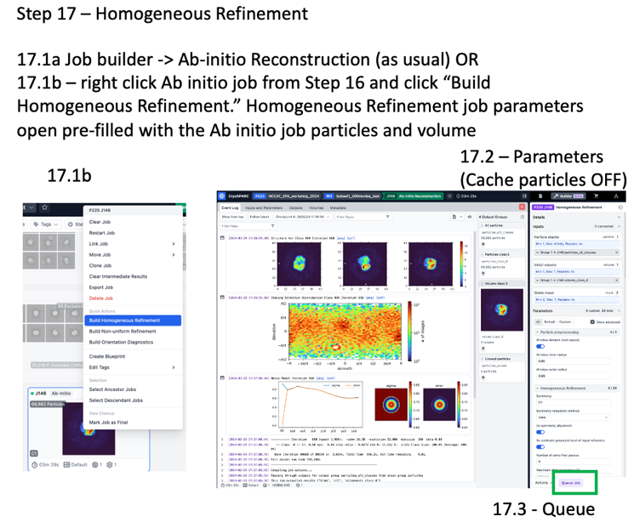
  - 17.2 – Parameters
    - Cache particles on SSD: OFF
    - Keep all others default

- Step 18 – Homogeneous Refinement with symmetry enforced
  - 18.1a – Open as usual with the Job Builder OR
  - 18.1b – Right click the Ab initio job from Step 16 and “Build Homogeneous Refinement” – the new job auto populates with the ab initio particles and volume output OR
  - 18.1c – right click the homogeneous refinement (C1) job from step 17 and click “clone”
  - 18.2 – Parameters
    - Symmetry: C2
    - Cache particles on SSD: OFF
    - Keep all others default
  - 18.3 – Queue

Part2
This part will use particles obtained by 2D classification for the whole dataset (1,663 micrographs). You will generate a 3D reconstruction (Part A) and assess the compositional and conformational heterogeneity (Part B) for the particles from this dataset using 3D refinement and classification tools in cryoSPARC. This part is split into two parts that will be performed independent from each other for time considerations.

Part A - In Part A, you will generate a “clean” consensus refinement by removing compositional heterogeneity (broken particles) by multi-class Ab initio refinement (Step 1). Each of the three Ab initio volumes and their corresponding particles will undergo homogeneous refinement without symmetry (Steps 2-4). You will identify a “good” class and repeat homogeneous refinement with C2 symmetry enforced (Step 5). This generates a “clean consensus refinement” that can be used for conformational analysis. Due to time restraints, you will start Step 1 (Part A) and then skip to Step 6 (Part B) while you wait for the Ab initio results.
Part 2 A visual guide

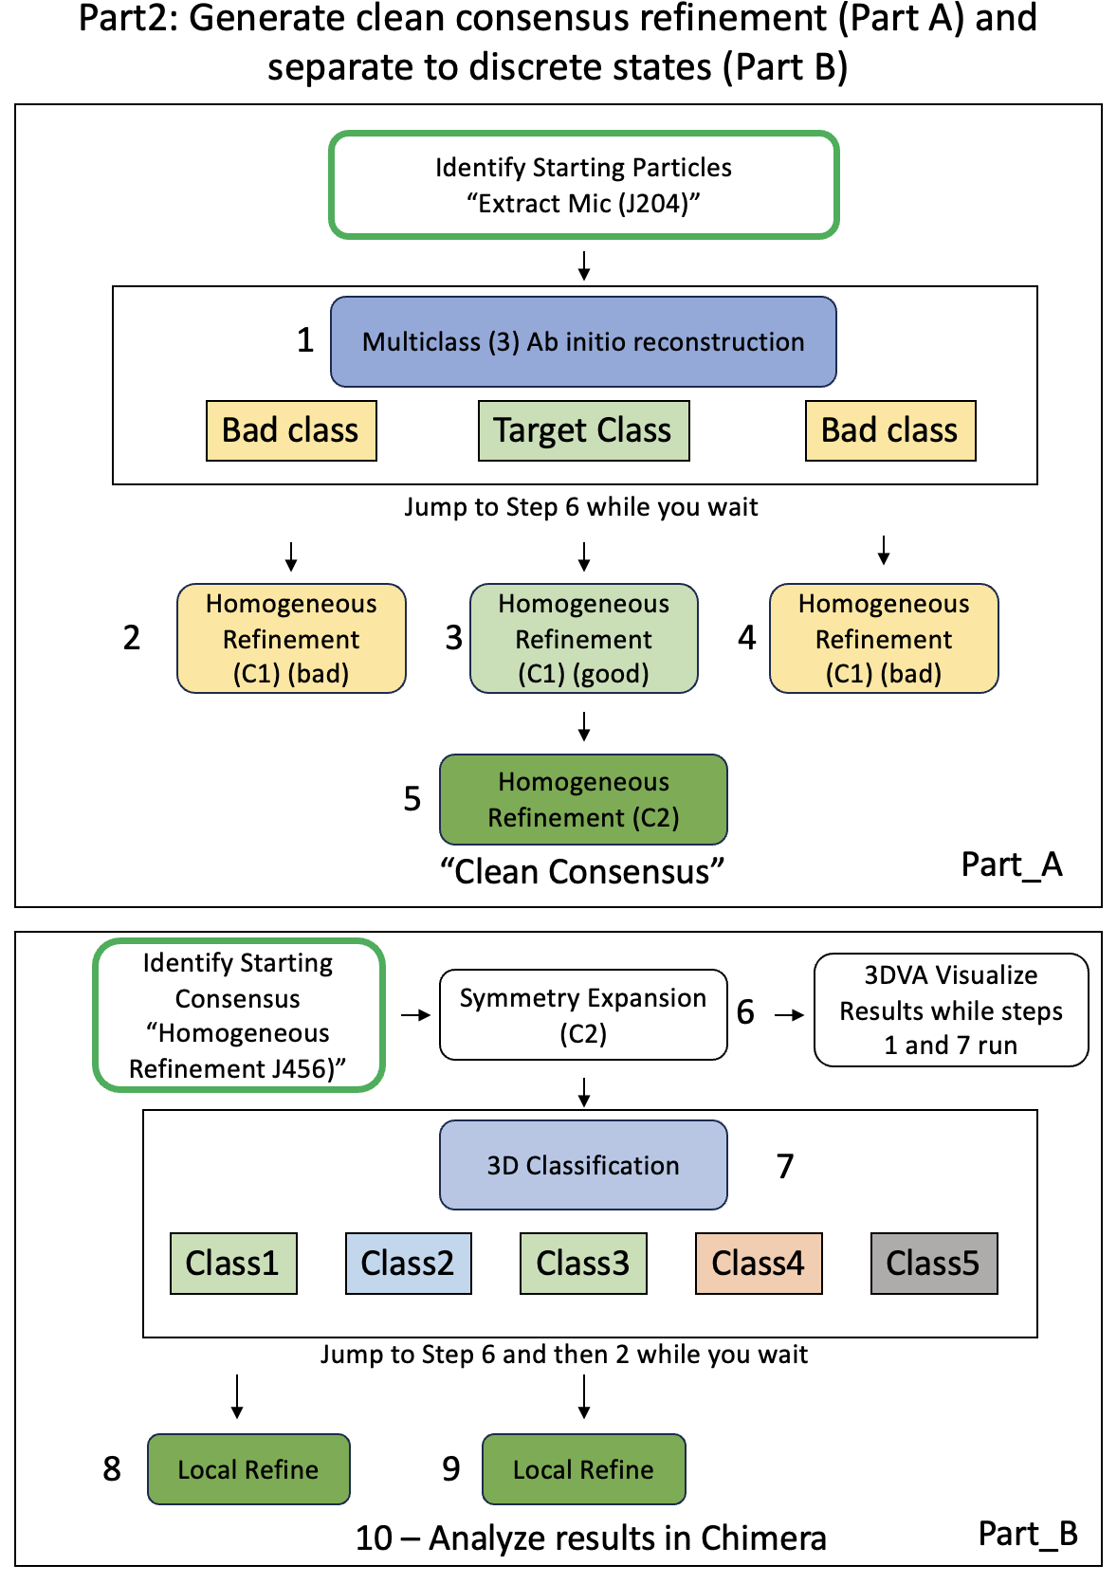

Part B – In Part B, you will use a “pre-baked” clean consensus refinement (C2 symmetrized), because Ab initio and subsequent refinements will take ~ 30 minutes. You will run symmetry expansion on the C2 symmetrized clean consensus refinement, followed by 3D classification. The results from 3D classification should be inspected in chimera to identify different conformational states, which will then undergo local refinement to generate final (hopefully) buildable maps corresponding to different conformations.
Part 2 B visual guide
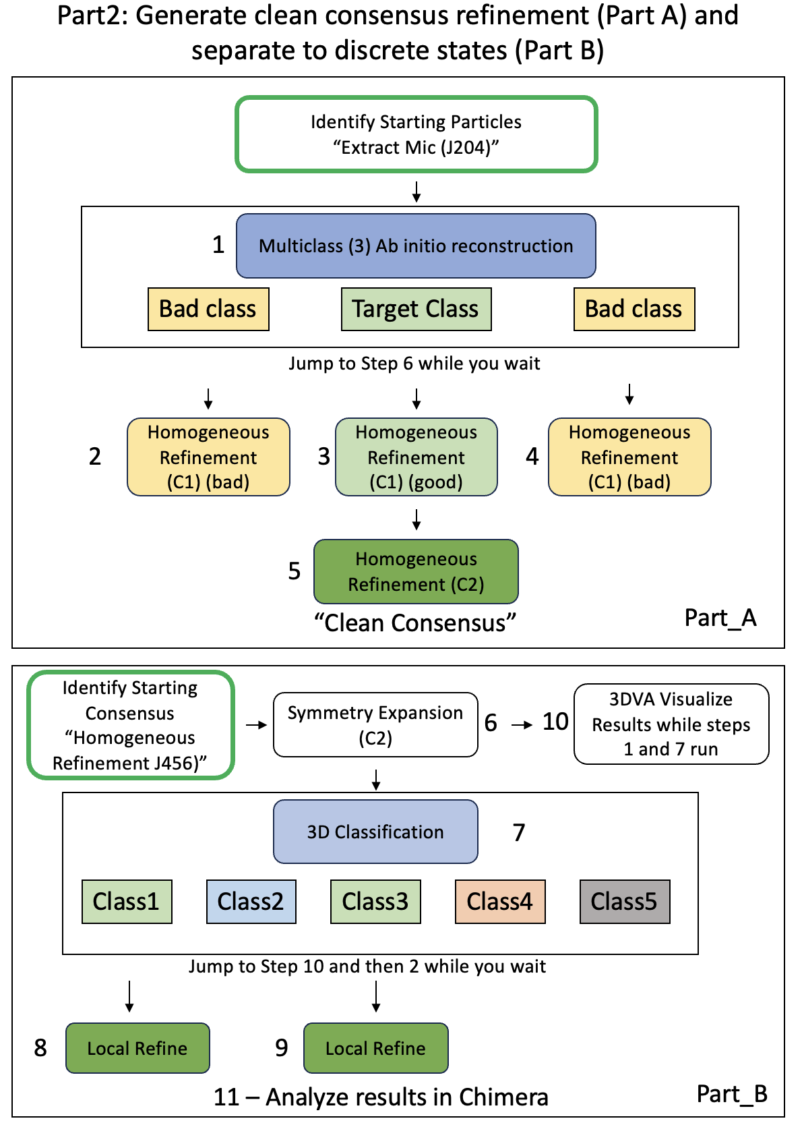

- Identify starting particles - Extract from Mics J204
  - The desired particles for 3D refinement and classification have already been selected and extracted for you. These came from 2D Classification (Step 14) from Part1 using the whole dataset.
  - Box size 150 (150 pixels x 1.12 Å/px = 168 Å box size)
  - No binning is used (fourier crop: blank)
  - For most datasets of larger proteins, it can be helpful to bin at the stage, because the box size will be larger. Binning was tested for this dataset and did not provide a significant speedup.
Multiclass Ab initio reconstruction
First start the job (steps 1.1a to 1.3 below) before reading the explanation.
The main purpose of Ab initio is to generate the initial volume for refinement (homogeneous refinement), which will be run in the next step. cryoSPARC Ab initio reconstruction can simultaneously generate multiple classes and separate particles into those classes, providing a 3D classification strategy. Let’s use multi-class Ab initio reconstruction to generate three initial models, assess heterogeneity, and separate particles into the three classes. For this particle stack, this job should generate one minor class corresponding to broken hemoglobin particles, another minor class corresponding to “bad” hemoglobin particles and a final class corresponding to “good” hemoglobin particles. We will run homogeneous refinement on each class to assess its quality and the good class will be used for downstream steps.
A major benefit of Ab initio reconstruction is the lack of model bias. One drawback is the lack of gold-standard FSC due to the lack of half-maps so there is no quantitative resolution metric for the final map.
Note we will all use the same random seed to ensure we get similar results.
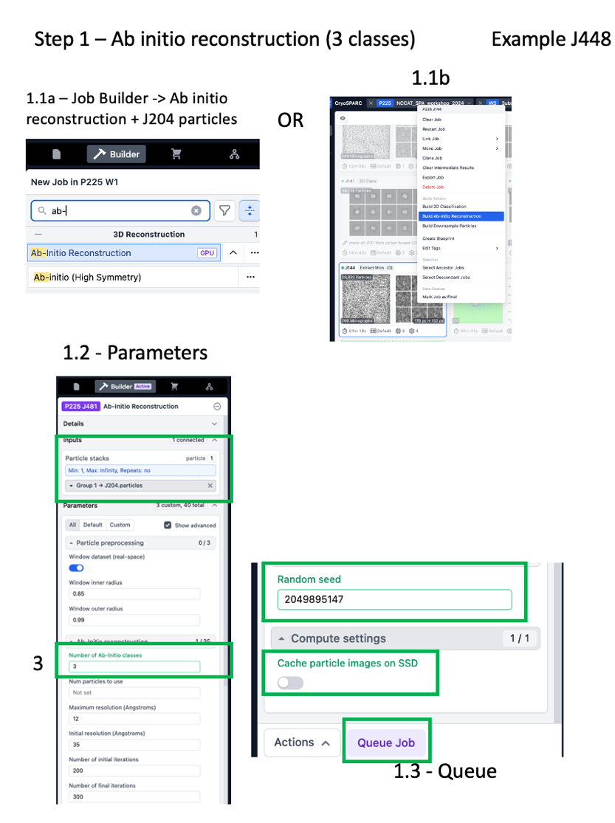
- Step 1 – Ab Initio reconstruction (Example J448)
  - 1.1a – Use the job builder to create the job and drag the particles from starting particles (Extract Mics J204) as input OR
  - 1.1b – Right click the starting particles (Extract Mics J204) and click “Build Ab-initio reconstruction” to automatically populate the newly built job with the Extract particle output
  - 1.2 - Parameters:
    - Number of ab initio classes: 3
    - Cache particles on SSD: OFF
    - Random seed: 2049895147
    - Note that it is often helpful to alter the initial and/or maximum resolution. The default parameters work well for our goal with this particle stack.
  - 1.3 – Queue & wait for the job to finish
    - In the meantime, start the Symmetry Expansion and 3D classification jobs (Steps 6 & 7 below)
  - 1.4 – Interpret results
    - Inspect the volumes. How do they differ?
    - Try to predict which class corresponds to the expected particle shape and take it to the next step.
    - Can you identify the monomeric v dimeric class?
  - Note this job took ~15 minutes to run previously

Homogeneous Refinement
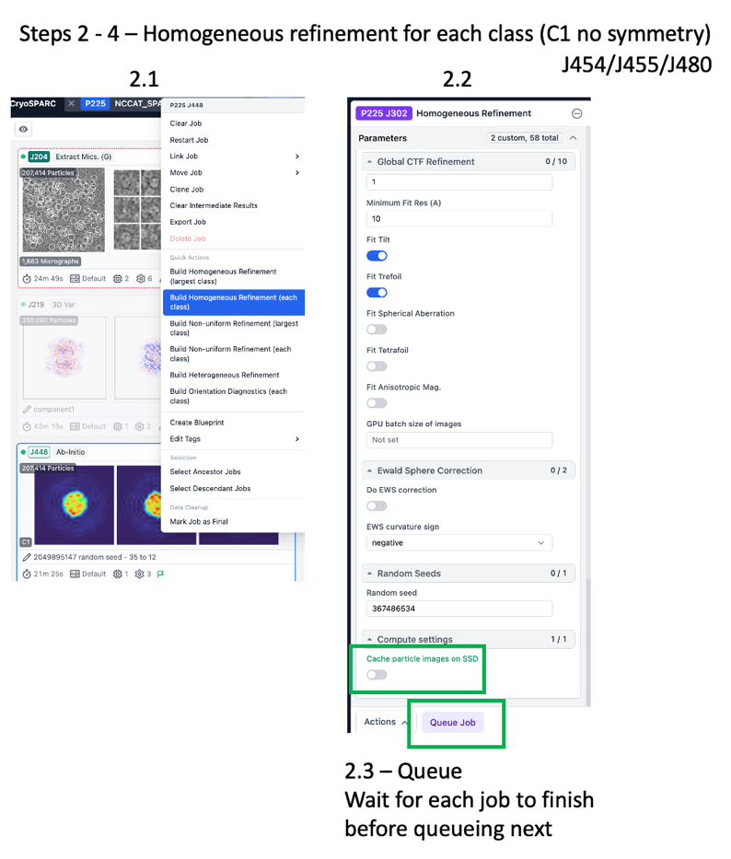
This job will generate a 3D reconstruction. The results can be highly dependent on the starting model and symmetry operator. We will run this job on all three ab initio volumes with their respective particle stacks with C1 symmetry (no symmetry). If we identify a good class that appears symmetric, we will repeat the refinement with that symmetry enforced. The C2 symmetrized refinement will be used for downstream processing and class separation.

- Step 2 – Homogeneous Refinement of Class 0 (C1) (Example J454)
  - 2.1 – Right click the Ab initio job from Step 16 and “Build Homogeneous Refinement (each class)” – the new job auto populates with the ab initio particles and volume output.
  - 2.2 – Parameters
    - Symmetry: C1
    - Cache particles on SSD: OFF
    - Keep all others default
  - 2.3 – Queue one job with above parameters, wait for job to complete
- Step 3 – Homogeneous Refinement of Class 1 (C1) (Example J455)
  - Repeat Step 2 with class 1
  - If you clicked “Build homogeneous refinement (each class)” in Step 2, Queue the second job now
- Step 4 – Homogeneous Refinement of Class 2 (C1) (Example J480)
  - Repeat Step 2 with class 2
  - If you clicked “Build homogeneous refinement (each class) in Step 2, Queue the third job now
- Inspect the results – Is there an obvious good class? Use it for Step 5.
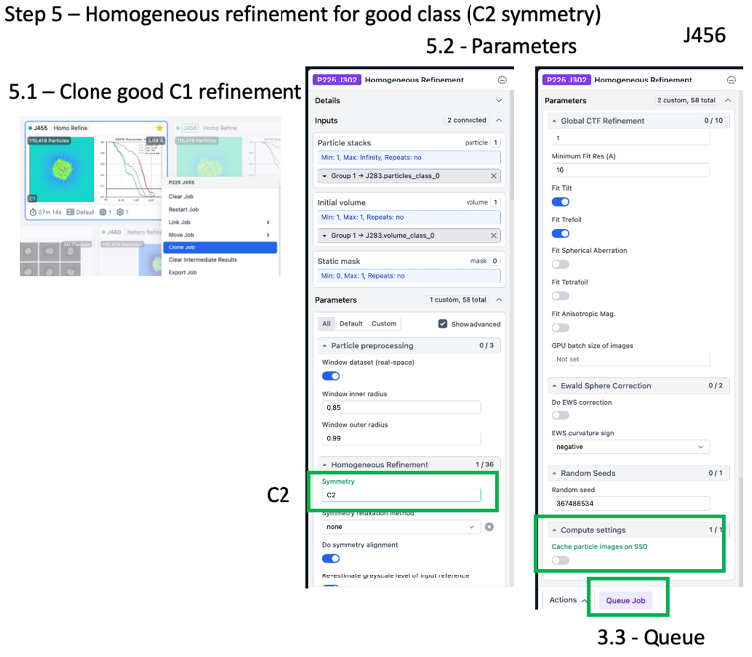
- Step 5 – Homogeneous Refinement of good class (C2) (Example J456)
  - 5.1 – Right click the good Homogeneous Refinement job from Steps 2-4 and “Clone” – the new job auto populates with identical parameters.
  - 5.2 – Parameters
    - Symmetry: C2 (changed)
    - Cache particles on SSD: OFF
    - Keep all others default
  - 5.3 – Queue
  - 5.4 – Inspect results - How does the job look with symmetry enforced?
  - This is the clean consensus refinement (symmetrized) that will be used for 3D classification.
Part B - 3D Classification of Clean Consensus Refinement with Symmetry Expanded Particles
First complete steps 6 and 7 below before reading the details.
Now that we have a “clean consensus refinement” it is time to assess the conformational heterogeneity. We will run 3D Classification on symmetry expanded particles.
3D Classification – In cryoSPARC, the 3D classification job is similar to Relion’s “classification without alignments and shifts (without GPU)”. In this job type, the program does NOT refine individual particle 3D alignments and shifts, but relies on the 3D alignments and shifts from a previous refinement. This means that the results are highly dependent on the quality of the parent refinement used as input.

Symmetry Expansion
The “symmetry expansion” job is run on an “n” symmetrized refinement (C2 for hemoglobin) and outputs n-fold particles (2-fold in this case). Each particle image is duplicated n-fold and rotated along its symmetry axis. This results in alignment of each protomer.

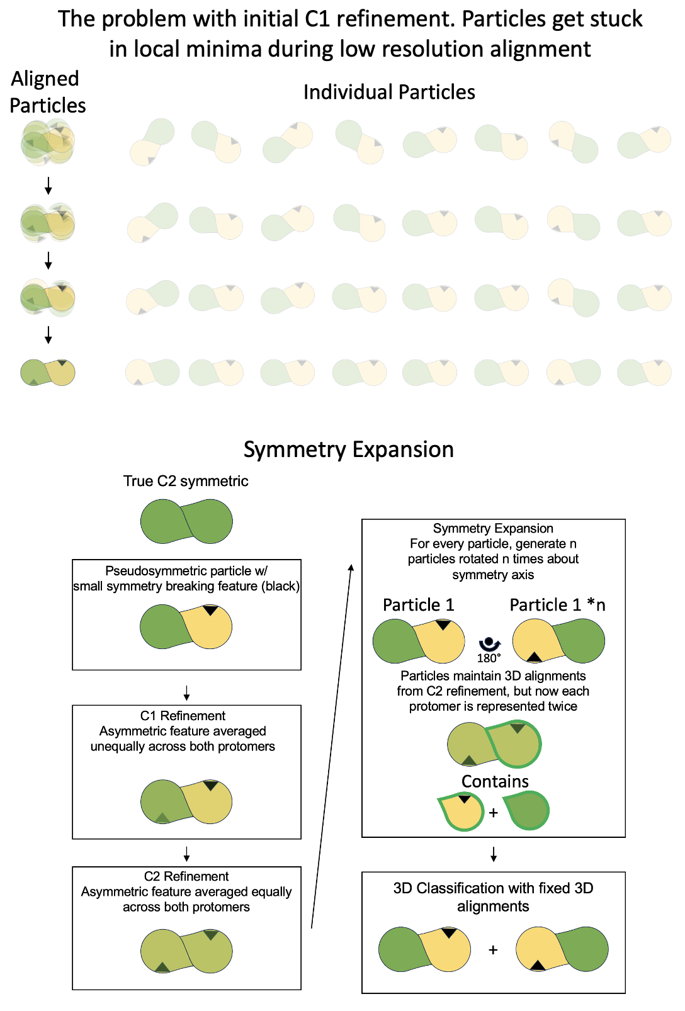
3D Classification in cryoSPARC does NOT have the option to enforce symmetry, which is why the input particles are first symmetry expanded. Symmetry expansion enables discovery of asymmetric conformational or compositional differences that are generally “averaged out” in symmetrized refinements. These small asymmetric differences can be referred to as pseudosymmetry and it is difficult for most refinement programs to align particles based on these differences because particles get trapped in local minima during alignment at low resolution.

Symmetry expansion and subsequent 3D classification without alignment enables separation of previously aligned particles based on small differences. The resulting particle stacks can be refined with C1 symmetry to give asymmetric maps.

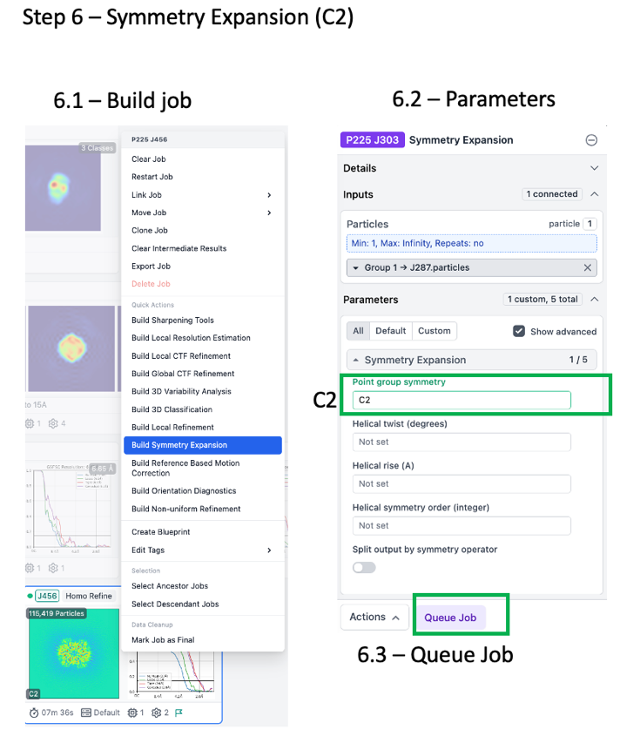
Identify starting Homogeneous Refinement (C2) J456. Steps 1-5 were completed and the “clean consensus” has been identified for you as input for Step 6.

- Step 6 – Symmetry Expansion (Example J461)
  - 6.1 – Right click the Homogeneous Refinement (C2) job J456, choose “Build Symmetry Expansion” and the job auto-populates with the Homogeneous Refinement (C2) particles output.
  - 6.2 – Parameters:
    - Point group symmetry: C2
  - 6.3 – Queue, job runs fast

- Step 7 – 3D Classification (Example J462)
  - 7.1 – Job Builder -> 3D Classification
  - 7.2 – Drag particles output from Symmetry Expansion to 3D Classification input
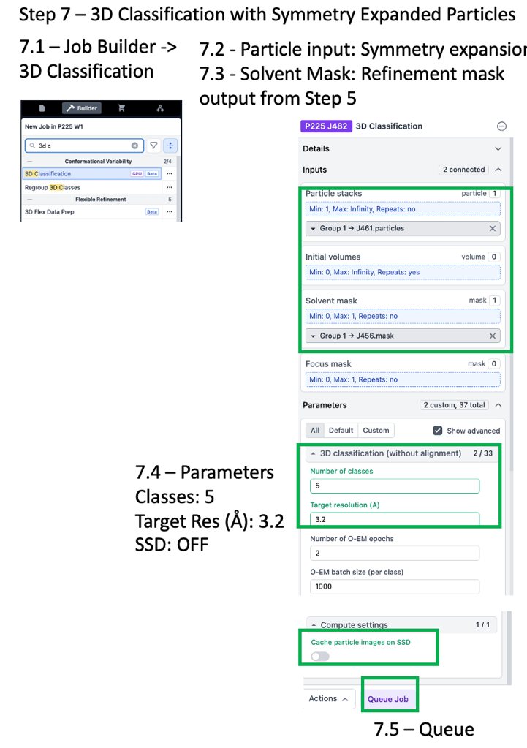
  - 7.3 – Drag mask from Starting Homogeneous Refinement (C2) (J456) to “Solvent Mask” input
    - Leave input Volume and Focus Mask blank
  - 7.4 – Parameters:
    - Number of Classes: 5
    - Target Resolution (Å): 3.2
    - Cache Particles on SSD: OFF
  - 7.5 – Queue & wait
  - 7.6 - Inspect results (KEY DATA INTERPRETATION STAGE)
  - This job may take 15-30 minutes to complete
  - In the meantime, go back to Step 1 Ab initio

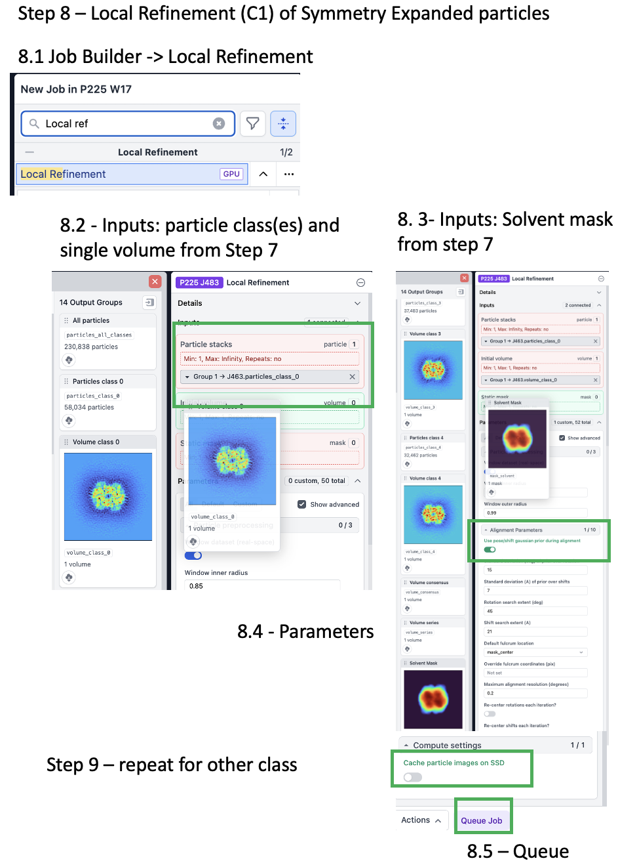
- Step 8 – Local Refinement (Examples J472 and J473) of one class
  - 8.1 – Job builder -> Local refinement
  - 8.2 – Drag the particle class # output and its volume from 3D Classification (Step 7) to Local Refinement input
  - 8.3 – Drag the Solvent Mask from 3D Classification (Step &) to Local Refinement Static Mask input
  - 8.4 – Parameters:
    - Use pose/shift gaussian prior during alignment: ON
    - Symmetry: C1 (default)
    - Cache particle images on SSD: OFF
  - 8.5 – Queue and wait
- Step 9 – Local refinement of other class (Examples J472 and J473)
  - Repeat Step 8 for the other class of interest from 3D Classification Step 7

- Step 10 – Visualize 3DVA results in Chimera
  - 3DVA and 3DVA display have already been run on symmetry expanded particles with the refinement mask. This is a good method to identify global conformational change, similar to 3D classification. The output of the “simple” display mode is a volume series that can be viewed as a movie in chimera.
  - 10.1 – Download J465 Volume Series 1, “keep” the download, and extract the .zip file
  - 10.2 – Open chimera (the rest of the instructions are for Chimera)
  - 10.3 – Open Volume Series Panel
    - Tools, volume data, volume series (volume series panel opens)
  - 10.4 - Open the volume series (3DVA display simple mode output results)
    - Click “Open” in volume series panel
    - Choose folder path “cryosparc_P225_J465_component_000”
    - Click first item in the list “J465_component_000_frame_000.mrc”
    - Hold “shift” button and click “J465_component_000_frame_019.mrc”
      - Note that “cmd + a” to select all and then open DOES NOT WORK on chimera v1.17.3 (and likely other versions)
    - Click “open” – the volume series opens
  - 10.5 - Change the threshold to 0.15
  - 10.6 - Change parameters in the Volume Series Panel:
    - Play direction - Oscillate
    - CHECK ON - Maximum playback speed (10) steps per second
      - Enter “10” into the field and hit the ENTER button on your keyboard
    - CHECK ON – Normalize threshold levels
    - CHECK ON – cache 30 renderings
    - Data cache size – Enter “1024” and hit ENTER on your keyboard
  - 10.7 - “Play”
  - View the movement

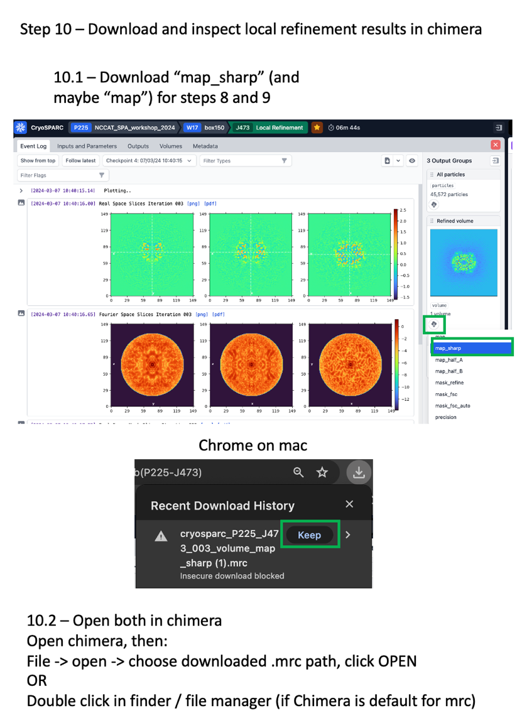
- Step 11 – Analyze refinement results in Chimera
  - 10.1 – The refinement job from Step 8 is open
  - 11.2 – Under “3 output groups” on the right, click the cloud download icon and a popup appears with volume download options. Click “map_sharp” to download. On mac with chrome, you may get a warning about an unsafe download and click “keep”
    - you may also want to download the full, unsharpened map (“map”) and/or half-maps to perform various types of post-processing
  - 11.3 – repeat for the other refinement
  - 11.4 - Open the two maps in chimera
  - 11.5 – You are ready to assess the conformational change and decide whether to proceed to model building
- In a real-world scenario, it can be good to further assess residual heterogeneity within these particle stacks. Tools like 3D classification, 3D-Variability Analysis, and heterogeneous refinement can aid in further analysis. Processing to obtain the final states is iterative and can take multiple rounds of trial and error to identify optimal parameters for discrete state separation.

Open 3DVA results to view conformational change

- Tools, volume data, volume series (volume series panel opens)
- Open the volume series (3DVA display simple mode)
  - Click “Open” in volume series panel
  - Choose folder path “cryosparc_P225_J363_component_000”
  - Click first item in the list (cryosparc_P225_J363_component_000.mrc)
  - Hold “shift” button and click “cryosparc_P225_J363_component_019.mrc)
    - Note that “cmd + a” to select all and then open DOES NOT WORK on chimera v1.17.3 (and likely other versions)
  - Click “open”
  - The volume series open
  - Change the threshold to 0.15

- Change parameters in the Volume Series Panel:
  - Play direction - Oscillate
  - CHECK ON - Maximum playback speed (10) steps per second
    - Enter “10” into the field and hit the ENTER button on your keyboard
  - CHECK ON – Normalize threshold levels
  - CHECK ON – cache 30 renderings
  - Data cache size – Enter “1024” and hit ENTER on your keyboard
- “Play”
  - View the movement

