Sample shipment agreement for COVID-19 projects

NCCAT is a BSL-1 (Biosafety Level 1) laboratory. All samples shipped to or worked on at NCCAT, SEMC and NYSBC premises should be classified as BSL-1.
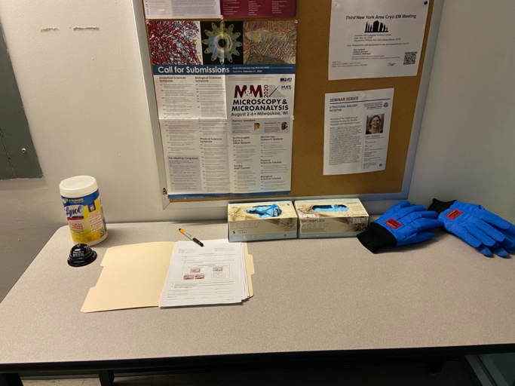
Please do set an appointment before delivery of samples and be in communication with your appointed center staff member. We are limiting personnel on site to maintain social distancing. When the staff member processes the sample, they will confirm receipt of the sample.

Samples should be dropped off at the designated sample receiving area or near the security guard station. See the designated NCCAT, SEMC, NYSBC EM sample drop off table to the right. The outside surfaces of containers should be sterilized with wipes on the table. Forms should be filled out electronically and submitted to the NCCAT User Office (nccatuseroffice@nysbc.org) and emg@nysbc.org.

Sample transfer may be done using a shipping container, transfer dewar or container. Each sample should be clearly labeled, and the outside container include the date and time, username, institution and NCCAT project ID.

If grids and grid boxes are submitted, then NCCAT and NYSBC uses a particular numbering system. Please note and order your boxes accordingly.

Bottom
User / Institution
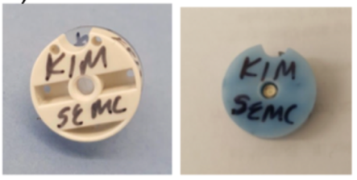
Top
User / Session date
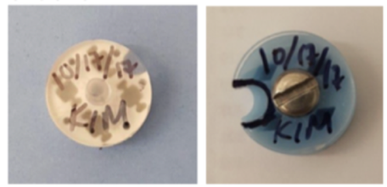
Grid position numbering

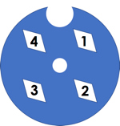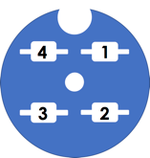

Acknowledgement

I verify that the samples were packaged by my person and that the samples comply with NCCAT biosafety and biohazard policies.

Signature: ____________________________________ Date: ________________
MM/DD/YYYY
Print Name: ____________________________________

