Sample shipment agreement

NCCAT is a BSL-1 (Biosafety Level 1) laboratory. All samples shipped to or worked on NCCAT, SEMC and NYSBC premises should be classified as BSL-1.
If shipping dewars, non-hazardous samples should be packed in a dry shipping dewar. Users should ship dewars via common carrier, such as FedEx. Also, include pre-paid return shipment label. (FedEx is preferred.)
It is the user's responsibility for packages sent to NCCAT until an NCCAT operational staff member confirms receipt.

NCCAT and NYSBC uses a particular numbering system. Please note and order your boxes accordingly.

Bottom
User / Institution
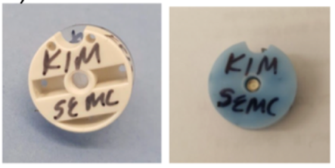
Top
User / Session date
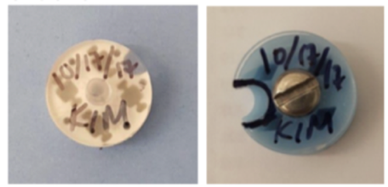
Grid position numbering

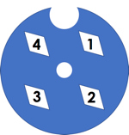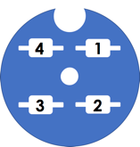

Acknowledgement

I verify that the samples were packaged by my person and that the samples comply with NCCAT biosafety and biohazard policies.

Signature: ____________________________________ Date: ________________
MM/DD/YYYY
Print Name: ____________________________________

